7. Anti-Aircraft Missile

Learning objectives:
- explain the missile design and key configuration parameters;
- describe in general terms the missile subsystems and functions;
- describe various types of missile propulsion systems.

7.1. Introduction
Anti-Aircraft Missile (or surface-to-air missile) systems are designed to meet specified operational requirements. The variety of requirements leads to different missile sizes and functional arrangements. Many of the differences among missile systems are therefore results of variations in tracking implementations and guidance concepts.
The purpose of a Anti-Aircraft Missile (AAM) system is to destroy threatening airborne targets. The system includes missile flight vehicle and supportive equipment such as launcher, any ground-based missile and/or target trackers, and any ground-based guidance processors. As a target approaches a missile launch site, a tracking system measures target motion relative to the missile. A fire control function determines the time and direction to launch, and the missile is propelled from the launcher by a propulsion system, usually a rocket motor. As the tracking system continues to measure relative motion, a guidance processor derives missile maneuver commands to book the missile to intercept the target. The maneuver commands are transformed into missile control- surface deflection commands by an autopilot and a control system supplies the actuator power to rotate the control surfaces. Aerodynamic lift on the missile generated by control-surface deflections produces maneuvers that are responsive to guidance commands. An explosive warhead is detonated on impact or upon proximity with the target. Missile flight performance depends on the mechanizations and the interactions among the various missile subsystems and the guidance concept.
AAM systems are the primary defense against airborne and theater ballistic missile (TBM) threats. Their objective is to deny enemy aircraft and TBMS access to friendly resources.
Air defenses consist of several layers of defensive capability, each with Long-range, high-altitude different missile system requirements. Long-range, high-altitude systems are required for widespread coverage of the field army and military bases. Medium-range systems with low- and medium-altitude capability are used to cover forward-deployed combat units and the rear areas of divisions and corps. Short-range systems, with the capability to destroy low-level threats, are used to defend airfields, depots, frontline armor, and moving columns.
Man-portable systems, also with a capability against low-level threats, are used for close-in defense.
The size of the missile flight vehicle is dictated largely by the distance it is required to fly (range) and the weight of its payload (warhead). The payload weight in turn depends on the expected miss distance, and miss distance depends on guidance accuracy. Different guidance implementations result in different potential accuracies. Missile size and configuration design requires that tradeoffs be made among all of these factors.
Current NATO AAMs range in mass from about 8 to 900 kg. The smallest missiles are hunched man-portable launch tubes; after launch they are guided by an onboard guidance system. The largest missiles fly to long range and high altitude and are supported by radars and guidance computers on the ground that interacts with the onboard guidance system.
An individual AAM system is called a fire unit. In general, a fire unit consists of the equipment and personnel to transport the system from one launch site to another; to search for, identify, and track airborne targets; to launch and guide missiles; and to reload launchers. A given fire unit can engage only those targets that come within range of the missile. Even a target that is within range sometimes cannot be engaged successfully because its position is such that the line-of-sight from the missile to the target rotates into angular positions, or angular rates, that exceed the capabilities of the tracking sensor. The locus of possible positions of the target at the time of missile launch that are within range and within tracking limitations establishes the missile system kinematic launch boundary. The kinematic launch boundary of any given missile system depends on target speed and flight path. The actual launch boundary is often smaller than the kinematic launch boundary because of additional limitations that depend on the sensitivity of the tracking sensor to radiation from the target and the geometric distribution of the spectral and intensity characteristics of radiation from the target (target signature). Also effective countermeasures employed by the target greatly decrease the size and shape of the launch boundary.
Fire units are located with overlapping launch boundaries at sites suited to defending friendly resources. Alerts (warning that a potential target is in the general area) and cues (giving the direction in which to look) maybe communicated among the fire units and centralized surveillance systems. As an enemy aircraft penetrates to within range of the search system of a given fire unit it is detected, identified as unfriendly, and the tracking sensor is locked on the target. The missile fire control system monitors target position and provides an indication of the time when the target enters the launch boundary. The fire control system also provides the azimuth and elevation angles needed to point the launcher.
The missile is launched by a switch operated by the fire unit crew. The missile propulsion system rapidly generates thrust and propels the missile along the launcher and into the air. Until the missile speed is sufficient for aerodynamic control, it flies ballistically. The tracking system continues to track the target and provide information on the position and motion of the target relative to the missile. The missile guidance system interprets this information and generates guidance commands that tell the missile how to maneuver to intercept the target. These maneuver commands are determined by the application of logic (guidance law) to the relative missile and target motion. The autopilot and control systems in the missile flight vehicle convert the guidance commands into aerodynamic control surface deflections that cause the missile flight path to turn. This process continues from the time guidance is initiated until the time of intercept. Because of inaccuracies, limitations, and time lags, however, the missile does not always impact the target but may fly close to it. The distance separating the missile and target at the closest approach of the missile to the target is the miss distance. The objective of guidance and control is to cause the miss distance to be as small as possible.
As the missile approaches the target, the fuze senses the presence of the target and detonates the warhead. If the miss distance is small enough and the fuze operates at precisely the right moment, the warhead explosion disables the target. If observation by the fire unit crew indicates that the missile was ineffective and the target is still within the launch boundary, another missile may be launched.
All AAM systems are not alike. The major difference is various approaches to missile guidance. All include some form of target tracking; some tracking sensors are large and located on the ground, whereas others are small and are carried onboard the missile. Different tracking systems sense different bands of the electromagnetic spectrum. Design of the guidance system has a significant impact on the design of the missile flight vehicle.

7.2. Missile
Major subsystems that may be included in the flight vehicle are guidance and control fuze and warhead, motor, and airframe. The guidance and control system is often subdivided into individual subsystems as shown in Figure 1. If a missile has a seeker, the onboard guidance system usually is composed of the seeker and autopilot.
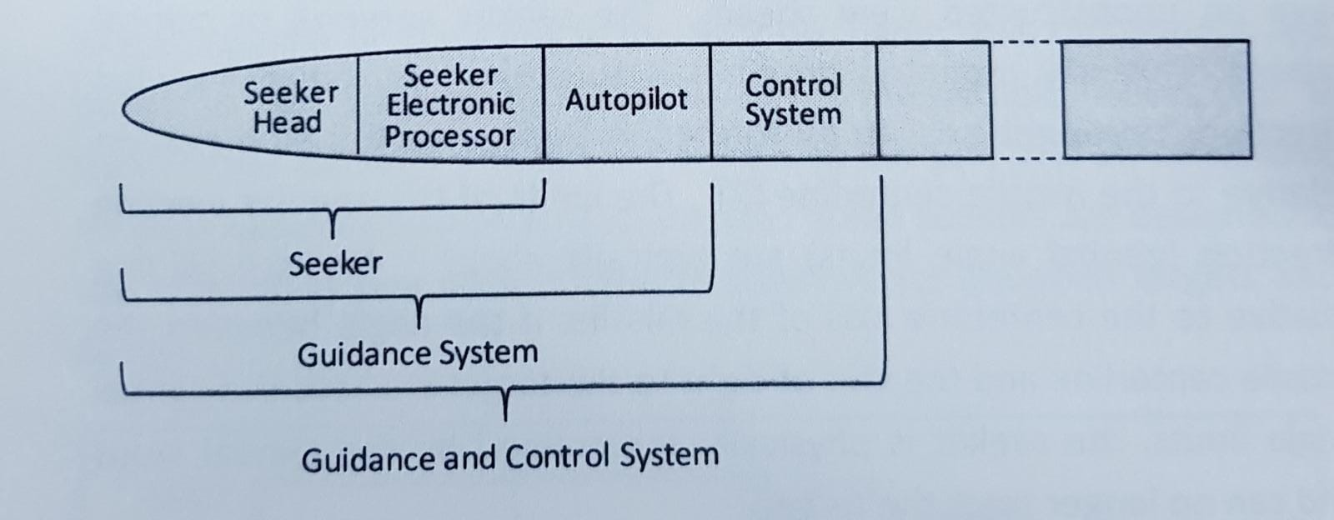
Fig. 1 Guidance and Control Terminology

Figure 2 is a longitudinal cross-section of a typical surface-to-air missile having all of these subsystems onboard. If a missile does not have a seeker, the only onboard guidance components may be antennas for receiving information from the ground-based guidance components and an autopilot to translate guidance information into control commands.
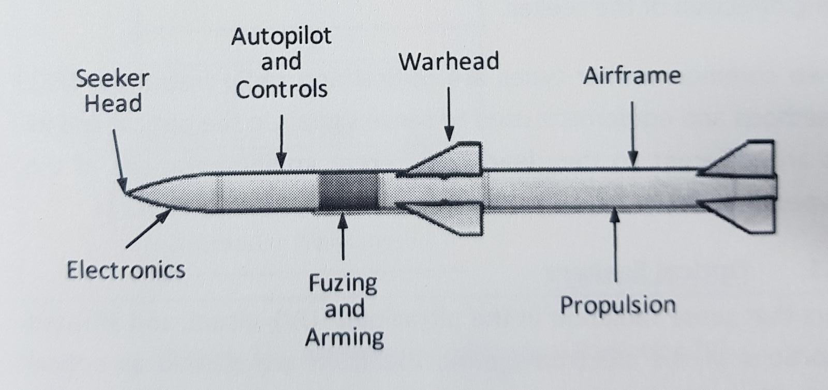
Fig. 2 Major Component Segments of a Homing Missile

7.2.1. Seeker
A missile seeker is composed of a seeker head to collect and detect energy from the target, a tracking function to keep the seeker boresight axis pointed toward the target, and a processing function to extract useful information from the detection and tracking circuits.
The seeker usually is mounted in the nose of the missile where it can have an unobstructed view ahead. The seeker antenna or optical system is usually mounted on gimbals to permit its central viewing direction (boresight axis) to be rotated in both azimuth and elevation relative to the missile centerline). The limits of the angular viewing direction (gimbal angle limits) are typically about + 40 to + 60 deg relative to the centerline axis of the missile. If the angle between the missile centerline and the line-of-sight to the target exceeds the gimbal angle limits, the seeker is physically constrained by the gimbal stops and can no longer track the target.
The gimbaled portion of the seeker head usually is stabilized to keep it pointing in a fixed direction regardless of perturbing angular motions of the missile body. The two most prevalent means of stabilization are to spin a portion of the gimballed components so that they act as a gyro and to use actuators to hold the seeker in a stabilized direction using control signals from gyros mounted on the gimbal frames. In either case, signals from the tracking circuitry are required to change the pointing direction of the seeker.
The two common seeker types are optical and radio frequency (RF). The methods and equipment used to sense signals in the optical and RF bands are different so they lead to different implementations of the two types of seekers.
Optical Seekers: seekers that sense radiation in the ultraviolet (UV), visual, and infrared (IR) portions of the electromagnetic spectrum are classed as optical seekers. The radiation is transmitted through the atmosphere from the target.
Radio Frequency Seekers: are essentially a radar in which the antenna is employed to collect RF radiation reflected horn the target. The RF power maybe generated by systems onboard the target, by a target illuminator on the ground or by a transmitter onboard the missile.

7.2.2. Autopilot
Typically, the output horn the seeker or ground-based guidance components is an electrical signal that contains information on the direction of the current heading error of the missile and some relative measure of the magnitude of the error. The autopilot converts the Steering error signals into control surface deflection commands (Figure 3) to correct the course of the missile.
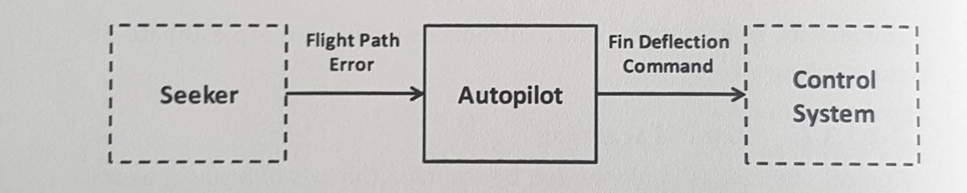
Fig. 3 Autopilot function
The autopilot is a link between the function that indicates a change of heading is needed (guidance processor) and the mechanism that can change the heading (control system). The guidance processor - which may be located on the ground or contained in the seeker signal processor, autopilot, or both-must accurately implement some prescribed guidance law to ensure that the control commands it develops will guide the missile close to the target.
The autopilot translates the commands produced by the guidance processor into a form suitable for driving the control actuators and limits the commands as necessary to maintain flight stability and airframe integrity. The design of the autopilot depends on the aerodynamics of the missile airframe and the type of controls employed. Since some guided missiles must perform over extreme ranges of flight conditions, the autopilot may be designed to compensate for some of the nonlinearities in the aerodynamics in order to ensure a stable system. If the missile design requires roll control, the autopilot may sense roll position or roll rate and issue appropriate control commands. Some missiles require control to compensate for the acceleration due to gravity; in this case the autopilot receives the necessary sensor data and determines the direction and magnitude of the commands required to compensate for gravity.
The autopilot may introduce airframe damping to prevent large overshoots in response to maneuver commands or to compensate for dynamic instabilities. It may contain amplifiers, integrators, and mixing circuits that send signals to the proper control surface actuators. In some applications missile maneuver commands may be produced solely on the basis of the seeker output.

7.2.3. Control
Once the guidance processor has determined the magnitude and direction of the error in the missile flight path and the autopilot has determined the steering command, the missile control system must adjust the control surfaces to produce the acceleration required to correct the flight path. This corrective acceleration is applied in a lateral direction (perpendicular to the missile flight path) to change the direction of the missile velocity vector (Figure 4). Intentional acceleration along the flight path to correct the magnitude of the velocity vector (for early or late arrival) is a potentially useful concept, but it is not presently used to guide surface-to-air missiles because of the complexity of throttling solid propellant motors.
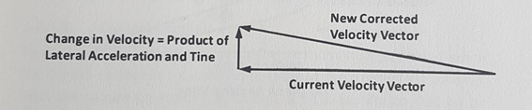
Fig. 4 Acceleration Required to Change Direction of Flight

7.2.3.1. Lateral Acceleration
Lateral acceleration of a missile requires a lateral force. The force required to alter the flight of a missile can be generated by different methods; however, the method currently employed in most United States (US) Army surface-to-air missiles is development of aerodynamic lift in a direction perpendicular to the flight path.
In an airplane, lift is produced primarily by the flow of air over the wing, as shown schematically in Figure 5(A). As the angle of attack - the angle between the chord of the airfoil and the velocity vector - is increased, the magnitude of the lift force is increased to the point at which stall occurs. Aerodynamic lift on a missile is analogous to lift on an airplane. Although the missile usually has very small wings or none at all it may have fins, and when the missile body combined with its fins is inclined by an angle of attack as shown in Figure 5(B), lift is produced. Lift force is approximately proportional to the square of the speed. Thus the relatively high speed of a missile is sufficient to achieve lateral accelerations many times the acceleration due to gravity (many g’s), even though the area-body plus fins-on which the aerodynamic pressure acts is relatively small.
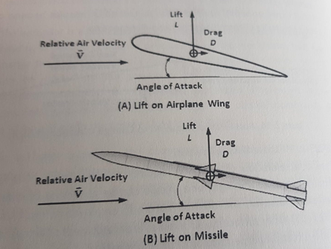
Fig. 5 Aerodynamic lift
For aerodynamic lift to be generated, the missile must achieve an angle of attack—angle between the missile centerline and the missile velocity vector. The steering command from the autopilot calls for a lateral acceleration to correct the error in the missile heading. This command may be a direct acceleration command, or it may beam indirect command, such as calling for fin deflection angles or fin actuator torques. In any case, it is a lateral acceleration that is to be achieved, and it is the task of the control system to cause the missile to assume an angle of attack that will produce that acceleration.
A moment, i.e., a force multiplied by a lever arm, is required to cause q missile to rotate to achieve an angle of attack. This moment can be developed by several means, but the methods currently used in US Army surface-to-air missile are thrust vector control and aerodynamic fin deflection. The latter is predominating. In thrust vector control the exhaust gases from the propulsion system are deflected laterally by a small angle so that the resultant thrust vector is no longer aligned with the center of mass of the missile. This misalignment causes a moment in addition to the translational force of the thrust. In Figure 6 the thrust force Fp, acts at a lever armarm to produce a moment on the missile. In aerodynamic fin deflection the airflow over the deflected control surfaces produces an aerodynamic moment on the missile that causes the missile to rotate relative to its velocity vector and thus achieve an angle of attack. Figure 7 illustrates the production of an aerodynamic moment on the missiles for two different locations of the control surfaces.
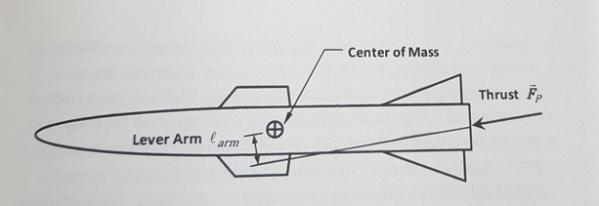
Fig. 6 Moment Produced by Thrust Vector Control

7.2.3.2. Canard Control
Figure 7(A) shows how an aerodynamic moment is generated when the control surface is a canard fin (located at the front of the missile). With the canard fin rotated as shown, a lift L (similar to that on an airplane wing) is developed on the fin itself. This lift, acting on the lever _{arm} relative to the missile center of mass, produces a nose-up moment when the fin is deflected as shown. The magnitude of the aerodynamic moment is proportional to the lift L that acts on the control surface. The lift in turn is dependent on the deflection angle of the control surface. Thus the control system can control the magnitude of the aerodynamic moment by controlling the angle of rotation of the control surface.
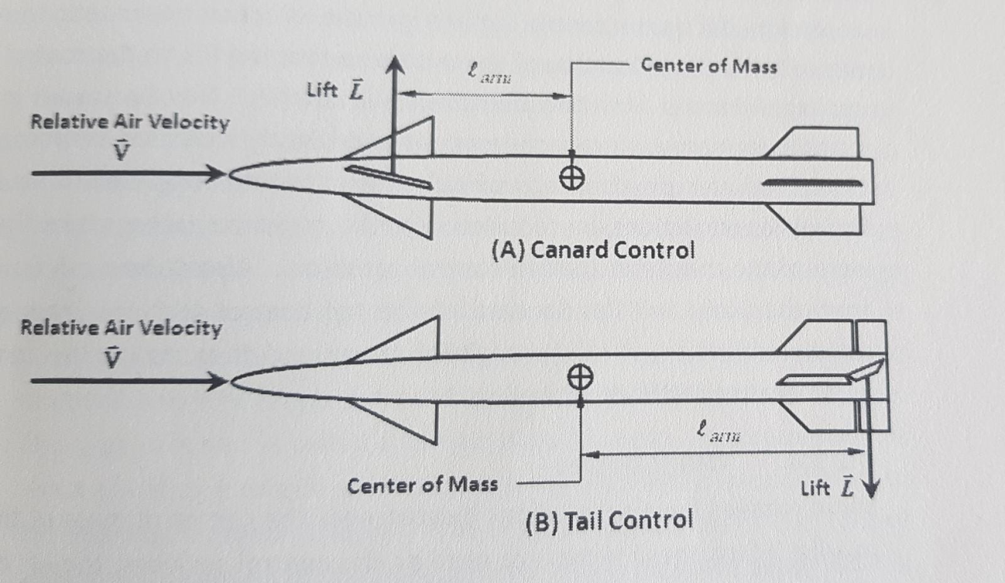
Fig. 7 Canard Control and Tail Control

When the missile has a finite angle of attack, a restoring moment is generated by aerodynamic lift on the tail surface. Since the tail surface is located behind the center of mass of the missile, this restoring moment is in a direction opposing the control moment generated by the canard fins. The magnitude of the restoring moment is approximately proportional to the magnitude of the angle of attack therefore, as the angle of attack increases-as a result of fin deflection-the restoring moment increases. When the angle of attack reaches the point at which the restoring moment equals the control moment, a balanced condition-called the trim conditions achieved. When the fins are initially deflected, a missile has a transient response that depends on the magnitudes of the moments, the moment of inertia of the missile, and the aerodynamic damping characteristics of the missile; the steady state result of the fin deflection is the trim angle of attack.
The fact that the lever armarmis relatively long results in a large aerodynamic control moment that rotates the missile with a high angular rate to the desired angle of attack. Fast response of the missile to maneuver commands is a very important characteristic for engaging maneuvering targets.

7.2.3.3. Tail Control
Figure 7(B) shows the use of tail surfaces for control. Either the entire tail fin is only the trailing edge is hinged as shown. With tail control the lift on the control surface is in the direction opposite to the desired lateral acceleration of the missile so that the lift on the control surface subtracts from the overall missile lift. This can result in slightly decreased lateral accelerations and slightly increased response time. Another disadvantage of tail control is that long electric and hydraulic connections are required from the guidance package near the nose of the missile to the tail control actuators. Also downwash flow from the body and fins forward of the tail control surfaces changes rapidly with changes in the angle of attack and thus makes the trim angle of attack difficult to predict.

7.2.3.4. Wing Control
Some missiles have small wings located near the center of mass of the missile. When these wings are used as the control surfaces, the lift on the wing—which may be a substantial portion of the overall missile lift-can be developed very quickly without having to rotate the entire missile to an angle of attack. Most supersonic missiles do not have wings.

7.2.3.5. Control Servomotor
The device that converts a control command horn the autopilot into a control surface deflection is called a servomotor, often shortened to servo. A control servo usually includes amplification of the commanded steering signal, application of the amplified signal to a solenoid-operated controller, application of controlled high-pressure hydraulic or pneumatic fluid to an actuator, and mechanical actuation (rotation) of the control surface.
Various types of auxiliary power supplies have been used to provide hydraulic or pneumatic pressure. The type most often used is a hot gas system in which propellant-type fuel is converted into high-pressure gas in a combustion chamber. This gas is then used to drive a hydraulic pump that provides power to hydraulic actuators, or the hot gas is used directly to power pneumatic actuators. The amount of fuel available to power the control system is limited; when the fuel is exhausted, the missile becomes uncontrollable.
In the operation of a pneumatic servo gas flows continuously horn the supply source and exhausts through the pneumatic servo nozzles with pressures P1, and P2. The exhaust flow is regulated by a flapper-nozzle valve. By decreasing the gas flow through one nozzle and increasing the flow through the other nozzle, the pressure is increased on one of the actuator pistons and reduced on the other. This pressure difference causes one piston to move down and the other to move up and thereby controls the deflection angle of the control surface. The control surface may be aerodynamically unbalanced about the hinge point such that a restoring torque is produced (aerodynamic hinge moment). The resulting deflection angle of the control surface is determined by the balance point between the aerodynamic hinge moment and the hinge moment generated by the actuator torque. This type of servo is called a torque-balance servo. A torque-balance servo provides a torque on the control surface that is proportional to the steering command signal. The angular deflection of the control surface is a function of the aerodynamic hinge moment acting on the surface and the power of the actuator. Large hinge moments require large, powerful actuators. Atypical mechanization of a torque-balance servo is illustrated in Figure 8.
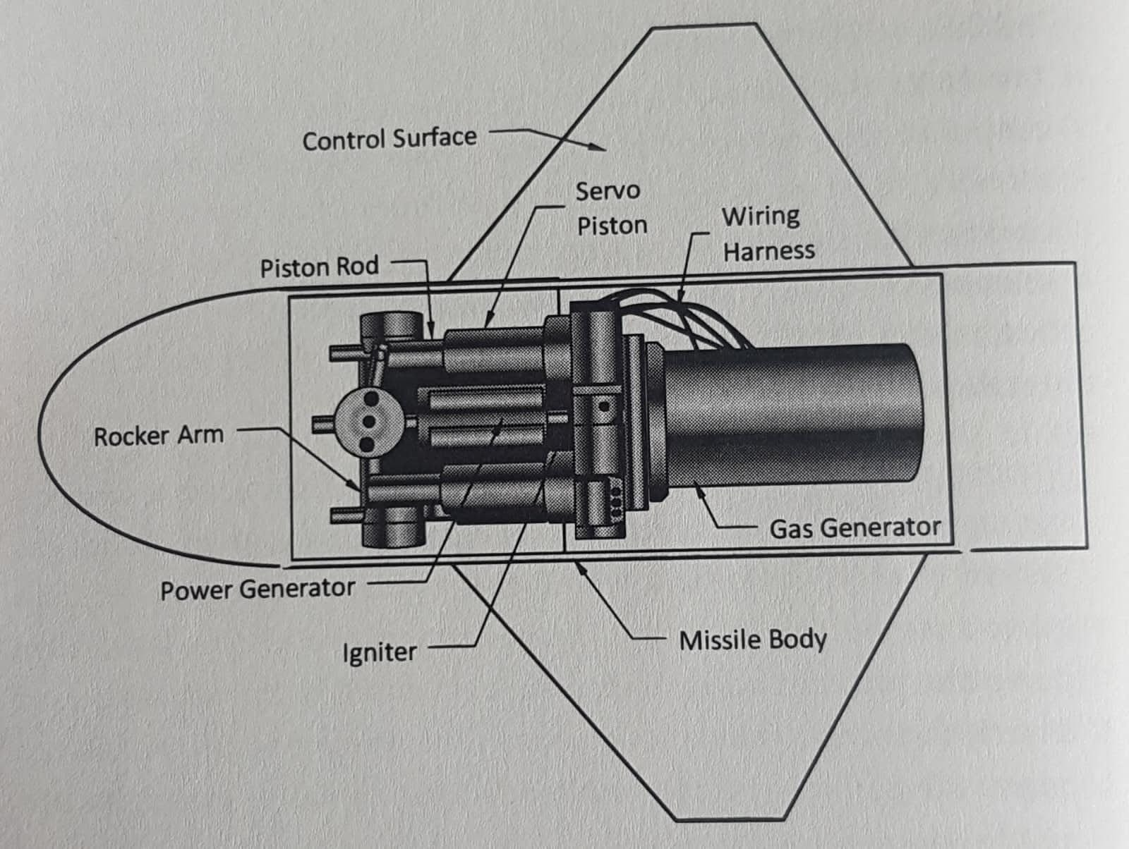
Fig. 8 Torque Balance Servo Configuration

The angular position of the control surface maybe sensed and returned to the amplifier to form a feedback loop. This type of control servo produces a control surface deflection that is proportional to the input steering command signal.

7.2.4. Warhead and Fuze
The ultimate objective of a guided missile is to disable or destroy the target. Warheads containing high explosives are typically used as the disabling or destroying mechanism. For most guided missiles the guidance accuracy is such that the missile will not always actually impact the target but will usually pass close to it. Near misses can be converted to successful intercepts by the use of proximity fuzes that sense the approach of the missile to the target and initiate a warhead detonation command.

7.2.4.1. Warhead
A bare high-explosive charge produces a high-pressure shock wave that radiates spherically from the burst point. The overpressure (pressure above ambient), the dynamic pressure (related to the air density and particle velocity behind the shock wave), and the time variation of these pressures interact with the target structure to cause damage. The relationship between the magnitude of blast damage and theradial distance from the burst point to the structural surface of the target depends on the weight and type of the high-explosive charge, the ambient atmospheric air density, and the design of the target structure. The ability of blast effects to cause target damage falls off sharply with increased range from the burst so sharply in fact that blast is not an effective damage mechanism unless the miss distance is very small or the high-explosive charge is very large.
To increase the radius in which significant target damage can be achieved, the explosive charge is enclosed in a metal case. On detonation of the charge the case breaks into fragments with high kinetic energy that carries them greater distances from the burst point. Fragments create damage by imparting energy and momentum to the impacted target structure and internal components. The effectiveness of fragments depends on their mass, velocity, material, and areal density (number of fragments per unit area of target surface). Fragment velocity falls off rapidly with range from the burst point, caused by aerodynamic drag (slowdown), and areal density decreases with range because at greater distances the same number of fragments covers a larger area. Thus the ranges at which fragments are effective are also limited but not as limited as the ranges for blast effects. If the warhead energy is distributed isotropically (equal distribution of energy in all directions from the burst point), the radius of war-head effectiveness is much less than it would be if the energy were focused. Because of their limited range of effectiveness, warheads with isotropic energy distributions are never used. Many different warhead concepts have been developed to focus the available warhead energy into preferred directions at the expense of other directions.
In terms of fragmentation pattern, the following three types of warheads are distinguished: warheads with circular patterns (Figure 9); warheads with axial patterns (Figure 9(B)); and warheads with radially directed patterns (Figure 9(C)). Circular pattern fragmentation warheads are most commonly used (Figure 9(A)). Their main advantages are the highest efficiency factor of explosive charge energy, arrangement of the warhead in any part of the missile, and engagement of targets at any side misses.
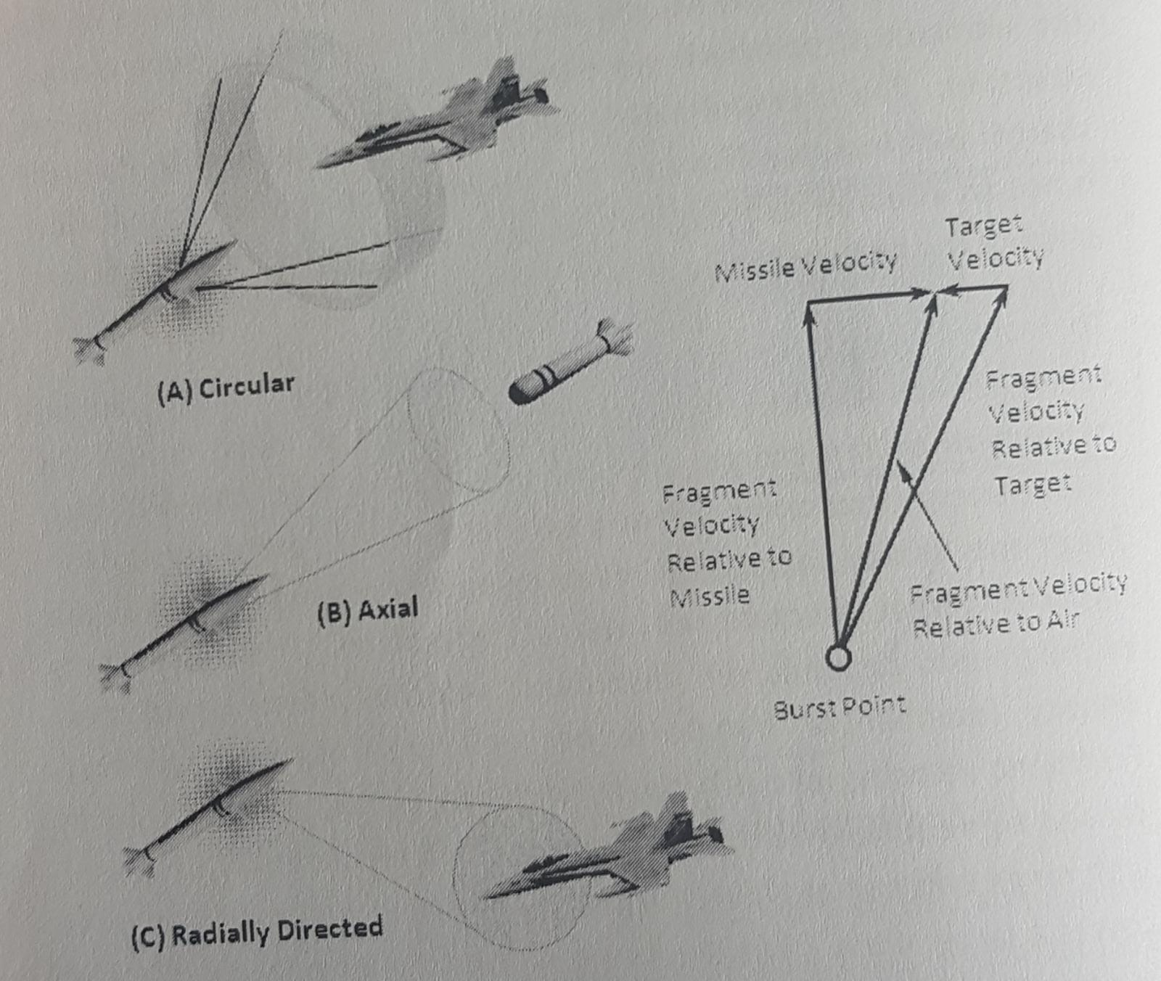
Fig. 9 Warhead Fragment Patterns

The warheads of missiles and rockets featuring high g-loads at launch usually employ controlled fragmentation envelopes created by grooving, using winded grooved strips, embrittled lattices produced, for example, by electron beam or laser treatment and the like. Warheads featuring relatively low g-loads at launch (n < 100), mainly SAM warheads, are fitted with assembled and bonded envelopes with prefabricated fragments in the form of cubes and cylinders made from steel or heavy alloys on the basis of tungsten with a 16 to 18 gr/${cm}^{3}$ density.

Shaped Charge
One concept that dramatically focuses the warhead energy is the shaped-charge warhead. This warhead is composed of many shaped charges directed radially outward from the centerline of the missile. Each shaped charge expels hypervelocity particles of a metallic liner into a very narrow, concentrated beam. The extremely high velocity of the fragments adds another damage mechanism, called the vaporific effect, which resembles the effect of an explosion occurring inside thetarget structure. Inspection of structures damaged by this mechanism shows aircraft skins peeled outward rather than the inward deformation that would be typical of slower fragments and external blast. In addition, between the shaped-charge spokes are areas of enhanced external blast effects, which reach too much greater ranges than blast effects from isotropic warheads.
Continuous Rod
Continuous rod warheads are designed with a cylindrical casing composed of a double layer of steel rods. The rods are welded in such a way that each end of a rod is connected to an end of a neighboring rod. As the rods are blown out radially by the explosion, they hang together forming a continuous circle. The objective of the continuous rod warhead is to cut long slices of target skins and stringers and thus weaken the structure to the point at which aerodynamic loads will destroy it. When the continuous ring of rods reaches its maximum diameter, it breaks up, and the lethality drops off markedly.
Continuous rod warheads are effective in tail chase engagements in which they can slice halfway through the fuselage of a small- to medium-sized target. Engagements from the forward hemisphere are less effective because the rod breaks up on impact with the leading edge structure of the wing.
Fragment
Most surface-to-air missiles use blast-fragment warheads. Although damage is caused primarily by the fragments, a bonus is obtained from coincident blast effects if the miss distance is small enough.
The approximately cylindrical metal warhead casing is fabricated by scoring or other means so that the explosion of the charge breaks the casing into many discrete fragments of uniform shape and size. These fragments fly out radially, approximately perpendicular to the centerline of the missile, and form a circular band of fragments that expands in diameter (Figure 9(A)).
Fragments are not very effective in causing target structural damage except at close miss distances at which a high density of fragments can be applied. Fragments are very effective, however, against target Components such as a pilot, fuel cells, wiring, plumbing, electronic Control equipment, electronic armament equipment, and engine peripheral equipment. Even though the fragments are focused into a relatively narrow beam, the expanding radius increases the area containing fragments and reduces the number of fragments per unit area. Given that the fragment beam intercepts a vulnerable component of the target, the probability of at least one fragment impacting the component depends on the areal density of fragments at the range of intercept.
In the design of a fragment warhead there is a tradeoff to be made involving the size (weight) of individual fragments. If the fragments are made very small (2 g (30 grains)), the fragment beam is composed of thousands of fragments, which produces a high areal density. But small fragments slow down in the air more quickly than huge fragments, and the number of target components that are vulnerable to small, slow-speed fragments is significantly less than for larger, faster fragments. Different warhead designs cover the spectrum from small fragments to large, rod-shaped fragments weighing several hundred grains.

7.2.4.2. Fuze
The fuze is the device that initiates the signal to detonate the warhead. Most surface-to-air missiles contain two fuzes—an impact fuze that is triggered by impact with the target and a proximity fuze that is triggered by a close approach to the target.
Focusing the warhead energy into a narrow beam increases its radius of effectiveness (lethal radius), but it does so at the cost of increased sensitivity to the timing of the detonation. To be effective, a warhead must be detonated at a time when its expanding fragment beam will intercept a vulnerable part of the target. In a typical nose-on engagement the time during which a detonation will result in fragment impacts on the target is approximately 12 ms. The fuze must sense the approach to the target and initiate the firing signal so that detonation occurs within that period. Often the fuze beam is swept forward at 4a greater angle than that of the anticipated dynamic fragment beam, allowing a short delay time between fuze triggering and actual warhead detonation as illustrated in Figure 10.
For a fixed fuze beam angle the optimum fuze delay varies considerably for different engagement velocities and aspect angles because of the variation in the angle of the dynamic fragment beam. Various schemes have been devised to estimate closing velocity as a basis for adaptively setting the fuze delay time (adapting to the situation in real time), but to reduce costs and complexity, often a delay time is selected that is a compromise among all anticipated engagement conditions.

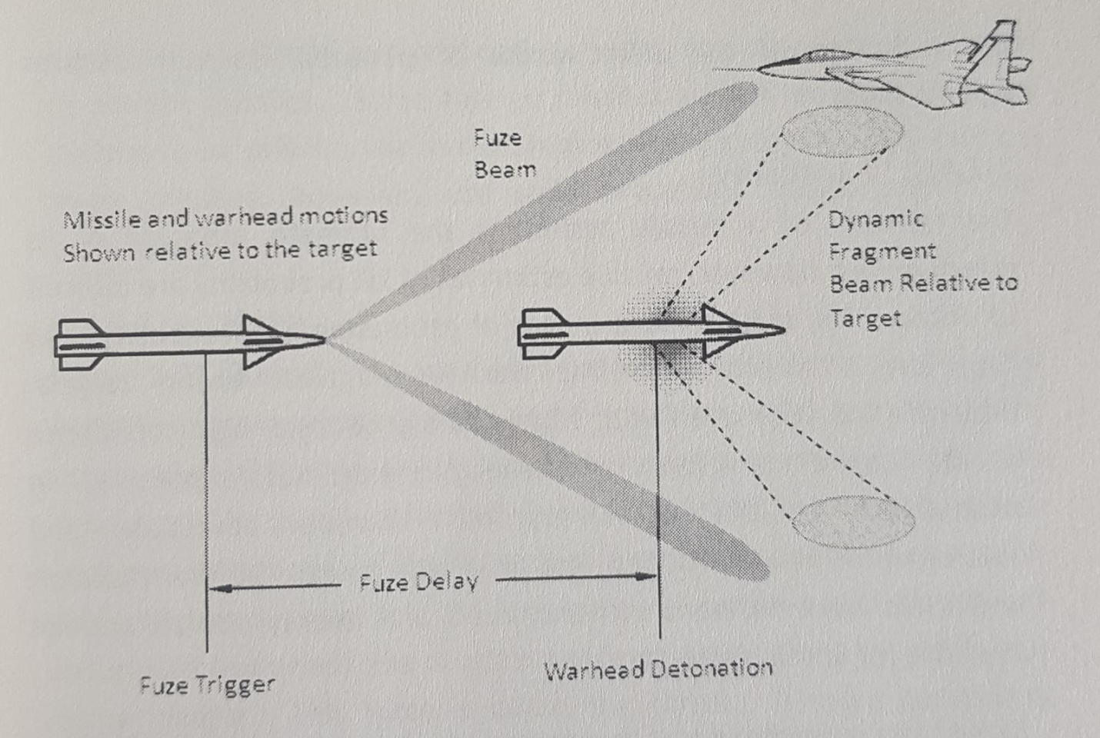
Fig. 10 Fuze and Warhead Relationships

A number of different types of fuzes have been developed. Early radio proximity fuzes had poorly shaped fuze beams that changed shape (in the wrong direction) when the relative velocity changed. Modem fuzes have well-formed, narrow, fixed beams. They may be active, i.e., RF or laser energy is transmitted and echoes from the target are received, or they may be passive, i.e., sensing IR energy radiated from the target or exhaust plume. Sometimes signals horn the seeker can be used to arm the fuze. A new generation of fuzes is being developed that takes advantage of onboard microprocessors and imaging seekers to determine the optimum fuze delay time based on relative velocity, aspect angle, and target size.
Fuzes usually are designed with some fixed maximum range that corresponds approximately to the lethal radius of the warhead to prevent fuzing on terrain, foliage, or sea waves in low-altitude engagements. A major consideration in the design of modem fuzes is the reduction of the effectiveness of potential countermeasure, against them.
7.2.4.3. Lethality
The lethality of a missile system is the ultimate measure of it, effectiveness; however, reliable estimates of kill probability are difficult to obtain. The most reliable means of estimating kill probability is to flight-test a missile with live warheads against drone targets Uncertainties arise even with flight testing because high-confidence results require many tests and testing is extremely expensive. In addition, it is difficult to reproduce combat conditions and environments in a controlled test on a test range. Different aircraft and TBMs have different vulnerabilities, and enemy aircraft are not available for use as drone targets.
Static tests in warhead test arenas provide data on. Warhead patterns and energy distributions, and on the vulnerabilities of various target components to the different damage mechanisms; however, dynamic and high-altitude effects are difficult to obtain without flight testing. Fuze tests are performed in the laboratory and in dynamic test arenas to provide data on fuze performance, but the proximity to disturbing factors such as the ground, target support structures, and instrumentation introduces uncertainty into the results. Arena testing alone cannot provide estimates of the kill probability of a missile system, but arena test results do provide valuable data on which to base computer simulations of the terminal engagement phase.
Terminal engagement simulations are used in studies of warhead and fuze design requirements, in studies of aircraft vulnerability, and to estimate the kill probability of a given missile design against a given target. Terminal engagement simulations typically contain very detailed data and calculations on warhead and fuze characteristics and on target components and their vulnerabilities. Kill probability simulations use the final outputs of missile fly out simulations as input data to establish relative positions, velocities, and attitudes between the missile and target in the endgame (terminal phase).

7.2.5. Propulsion
A rocket motor is the usual source of missile propulsion. Some of the early US Army surface-to-air missiles used liquid propellants; there have been studies of and proposals for using ram-air-augmented solids in current missiles. Some foreign missiles as well as older US Navy surface-to-air missiles use ram-jet motors. All current US Army surface-to-air missiles, however, use solid propellant rocket motors for propulsion.

7.2.5.1. Motor
Figure 11 illustrates a typical solid propellant rocket motor. The solid propellant grain contains a fuel and an oxidizer, which burn inside the ‘combustion chamber to create high-pressure, gaseous combustion products. The gas is exhausted through a converging-diverging nozzle at supersonic speed. If the incremental pressures acting on the inside and outside surfaces of the combustion chamber and nozzle are integrated (summed), the result is net force acting along the axis of the rocket motor. This force is called the thrust. A more convenient method of calculating and analyzing rocket motor thrust is based on the principle of conservation of momentum.
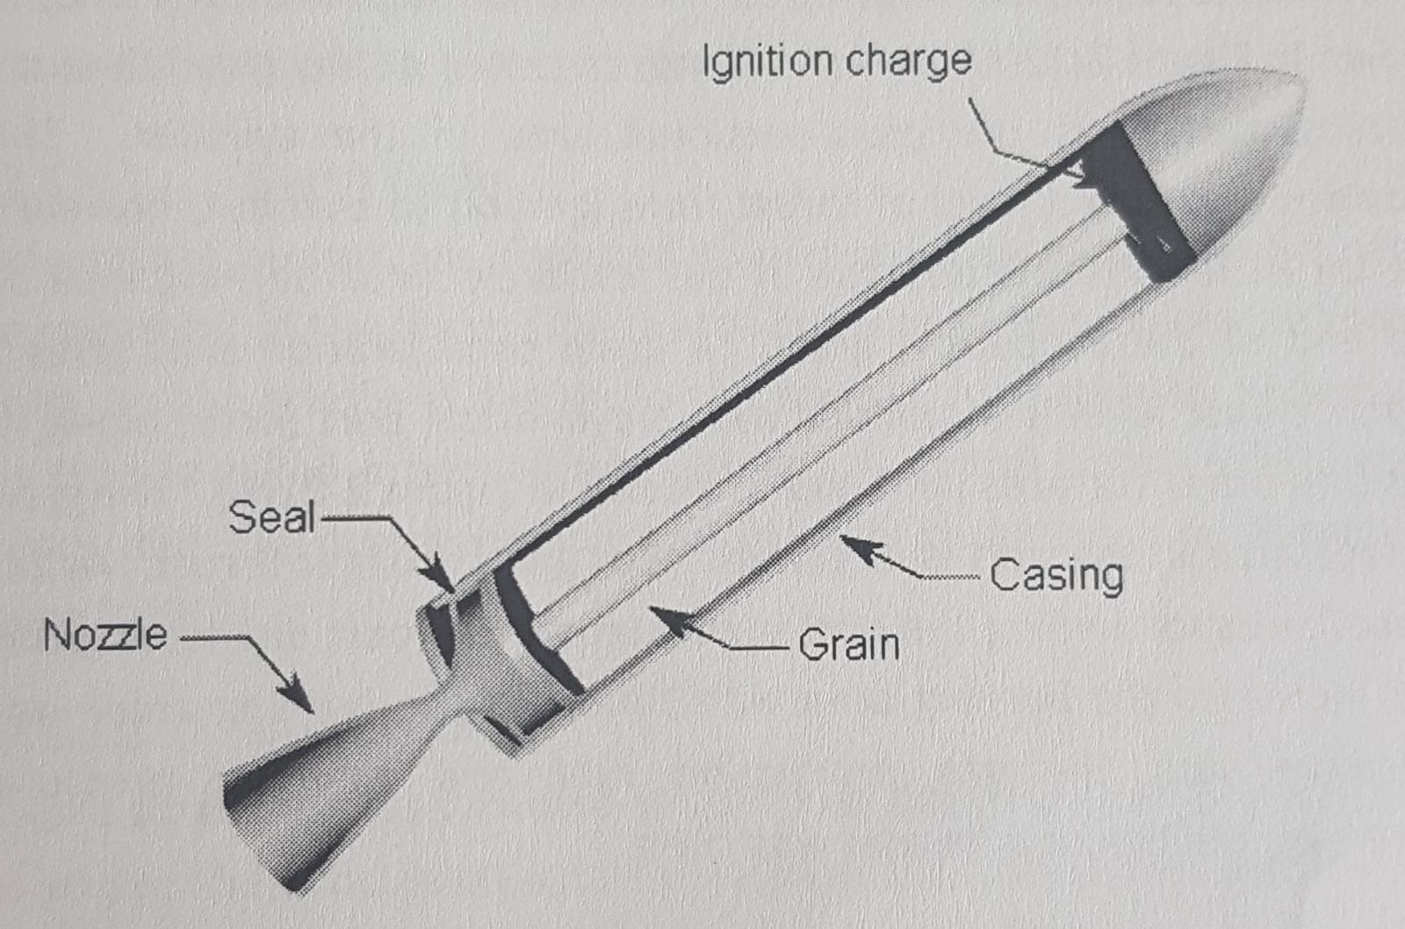
Fig. 11 Solid propellant rocket motor

The momentum imparted to the exhaust gases must be equal and opposite indirection to the momentum imparted to the missile; the force that acts against the missile in one direction and against the exhaust gas in the opposite direction is equal to the mass rate of flow multiplied by the velocity of the gas (rate of change of momentum) relative to the vehicle. The thrust is composed of the force that results from momentum change minus a pressure imbalance, which results from the fact that ambient atmospheric pressure cannot exert a force on the missile in the region of the nozzle exit area. Both views, (1) integration of pressures and (2) momentum rate plus atmospheric pressure imbalance, predict the same values of thrust applied to the missile.
The time history of the thrust of a solid propellant rocket motor depends on the design of the propellant grain. If the grain surface area that is exposed to combustion is large, the rate of generating and exhausting gases is high, and the resulting thrust is high. Conversely, a low thrust for a longer duration can be obtained with a given propellant if the exposed burning area is small. The size of the burning area depends on the original shape of the propellant grain and on the application of inhibitors to surfaces on which burning is to be prevented. Inhibitors are composed of materials that are essentially inert or that burn very slowly.
A cylindrical solid grain with all surfaces inhibited except one end, as shown in Figure 12(A), bums at a uniform rate. At any given time the burning surface is the cross-sectional area of the cylinder. This provides a constant level of thrust from ignition to burnout; however, the thrust level is low because of the relatively small burning area on the end of the propellant grain. A grain configuration that gives a higher thrust level is a cylinder with a cylindrical port (hole) along its axis and other surfaces inhibited as shown in Figure 12(B). The grain surface area in the port is larger and thus gives a larger thrust. As the propellant surrounding the port is consumed, the port diameter grows and increases the burning area with time. As the burning area—and therefore also the gas production rate and chamber pressure increases, the thrust increases with time.
A rocket motor whose thrust increases with time is said to have progressive burning characteristics. A more neutral burning characteristic is obtained when the cross-section of the port is shaped like a star, as illustrated in Figure 12(C).
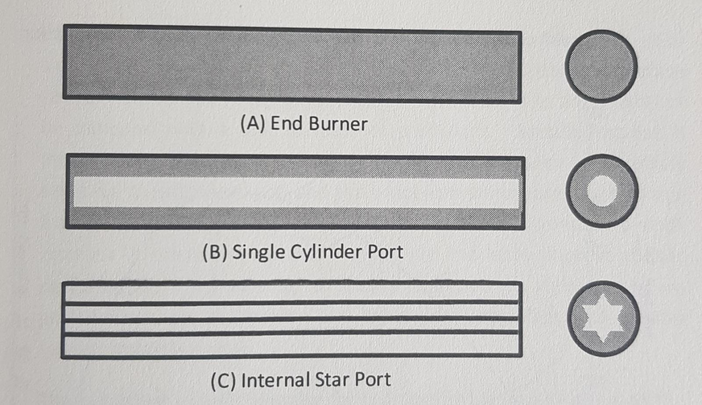
Fig. 12 Propellant Grain Configurations

A solid cylindrical grain with no inhibited surfaces has regressive burning characteristics, i.e., the thrust level decreases with time. Many different grain designs have been developed in order to produce different shapes of the thrust history curve.
Boost Glide
Some rocket motors are designed to provide their total impulse near the beginning of the flight. The motor burns out and provides no more thrust, so the missile glides on to the target. A propulsion system of this type is called a boost-glide system. A typical boost-glide thrust history and the corresponding missile velocity history are shown in Figure 13(A).
Boost Sustain
When a small thrust is provided to continue after the main boost thrust has ended the propulsion system is called a boost-sustain system. A typical boost-sustain thrust history and the resulting missile velocity history are shown in Figure 13(B).
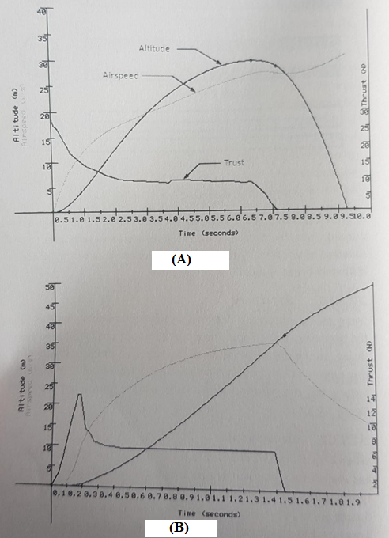
Fig. 13 Typical Boost-Glide and Boost-Sustain Histories
The drastic change in thrust levels from boost to sustain can be accomplished in different ways. In a two-stage propulsion system the missile contains two different rocket motors, a boost motor and a sustain motor, often mounted in tandem. The boost motor is ignited first and the missile is accelerated. When the boost motor burns out it is separated and drops away from the missile. The sustainer motor is then ignited to maintain the missile speed. Other boost-sustain designs use the same rocket nozzle for both thrust phases, with the change in thrust level being accomplished by the grain configuration and the arrangement of the combustion chamber.

Specific Impulse
Specific impulse is one of the most important parameters used to describe the performance of a rocket motor. It can be defined as the thrust that can be obtained per unit of gas flow rate. For simulation purposes an equivalent but more useful definition is the amount of impulse (integration of thrust with respect to time) that can be obtained with a unit of mass of propellant. Specific impulse is important to missile performance because performance is extremely sensitive to missile weight, and the propellant contributes such a large fraction of missile weight. With a given missile configuration a small increase in propellant specific impulse can markedly improve missile performance. Conversely, a missile designed to deliver a given performance can be smaller and lighter if a propellant with greater specific impulse is used.
The published specific impulse for a propellant is usually given on the basis of an ideal nozzle and specified nozzle exit pressure, grain temperature, and chamber pressure Delivered specific impulse is the specific impulse actually achieved by a rocket motor under the conditions of the test, and it may differ significantly from the standard published value for the propellant.
Typical values of delivered, sea level specific impulse for solid propellant motors vary from 1570 to 2350 N∙s/kg, depending on the composition of the propellant and motor design. In a boost-sustain configuration using a single nozzle for both thrust levels, the design is usually optimized for the boost phase; thus the specific impulse for boost is often higher than for sustain.

Temperature Effects
The burning rate and the total impulse of a rocket motor are affected by the initial propellant grain temperature. Figure 14 shows typical effects of grain temperature on thrust history. Variation of total impulse, i.e., the area under the thrust history curve, is only about + 3% over the range of temperature extremes between -57° and 76°C [16]. For a given missile firing, the grain temperature is not always easy to determine because it depends on the environmental conditions surrounding the missile over several hours before firing.
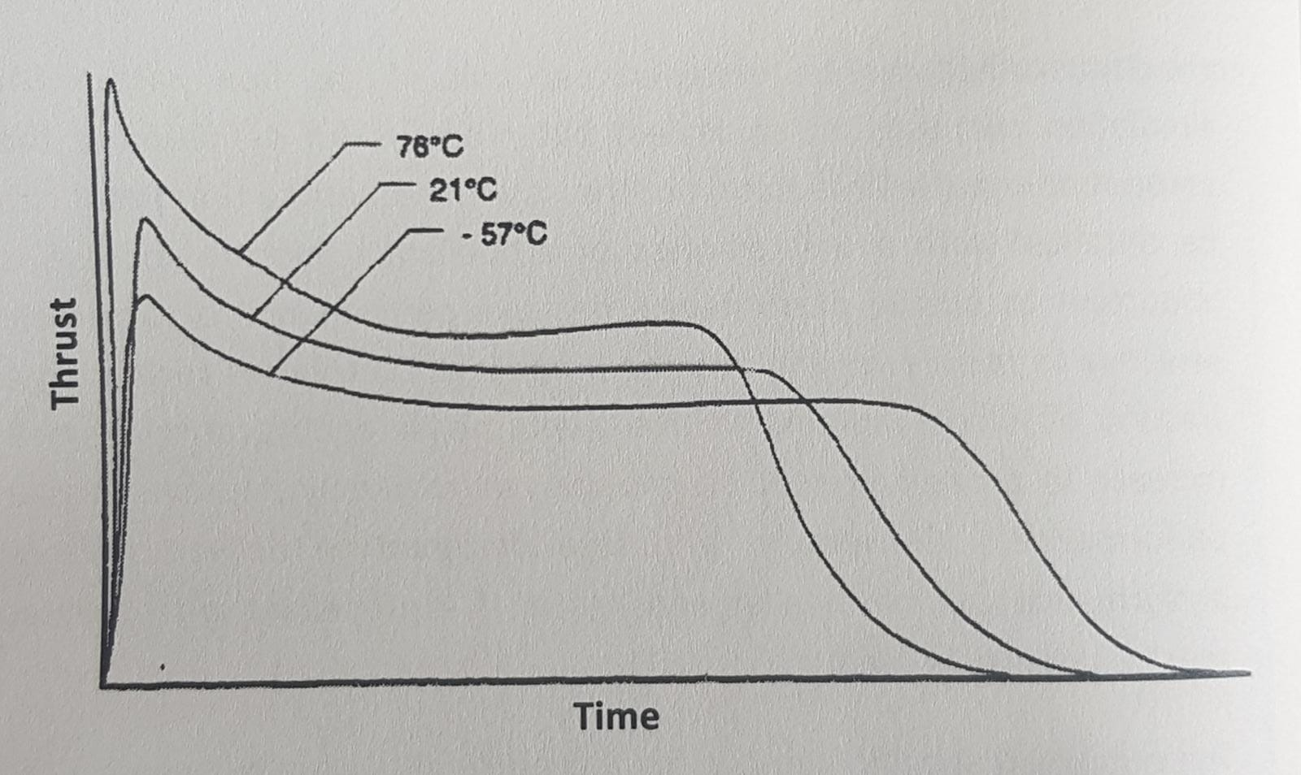
Fig. 14 Effect of Temperature on Thrust History

7.2.6. Tube Launch Ejection
Missiles that are shoulder fired must be designed to prevent the rocket plume from causing injury to the firer. These missiles are ejected from the tube by using an ejection charge that bums out within the tube. After exit from a tube, the ejection charge casing drops away from the missile, and if an internal acceleration switch is closed—indicating successful ejection—the boost motor is ignited at a safe distance from the fire.

7.2.7. Propulsion Design and Operational Implications
The selection of a particular propulsion system configuration for a new missile system is strongly influenced by the design tradeoffs and operational requirements of the design. For example, ejection system requirements for shoulder-fired missiles are dictated by launch crew safety. Tradeoffs among the advantages and disadvantages of boost-glide and boost-sustain configurations involve interrelations among many factors. Boost-glide is the most straightforward and simple propulsion system, but the speed is either increasing rapidly during boost or decreasing rapidly during glide, and speed changes (accelerations) make guidance more difficult. Also, to achieve enough speed during boost to carry the missile to a long range during glide may require a peak speed so high that aerodynamic heating of the radome or optical dome could cause structural problems or interfere with signal transmission. The guidance law used in the missile design, combined with the shape of the thrust history, determined the flight path of the missile relative to the target. Undesirable flight paths (resulting from certain thrust histories) can cause loss of seeker lock because of gimbals angle constraints.
A decision to use boost-sustain propulsion requires further decisions regarding how to mechanize it. Among the choices are the use of two stages with stage separation after boost, the use of two combustion chambers with a single, non-optimum nozzle, or alteration of the nozzle conjuration between boost and sustain.
Many of these considerations relate to design simplicity, cost, and efficiency. Other considerations apply to operational and performance factors such as man-portability launch crew safety, preventing falling boost stages from striking friendly troops, maximum missile range, and guidance accuracy.

7.2.8. AIRFRAME
The airframe consists of the structural and aerodynamic components of a missile. For purposes of missile simulation, the important features of the airframe are its configuration, weight and moments of inertia.

7.2.8.1. Typical Configurations
A typical surface-to-air missile airframe is a cylindrical tube structure that houses all the missile subsystems and supports the control fins, stabilizing fins, and wings (if any). The missile typically consists of ~ segments, containing different subsystems, attached end-to-end. The cylindrical frame may be an integral part of the segment it houses. The method of control influences the airframe configuration. Configurations with canard control, tail control, and wing control are discussed in subsection 7.2.3. Airframe deflection, i.e., aero elastic effect, is an important consideration in missile design but is beyond the scope of this book.
The front end (nose) of the missile is usually a radome or optical dome to house the seeker. Radomes, housing RF seekers, have pointed noses to minimize drag under supersonic flow conditions. Optical domes, housing optical seekers, are usually hemispherical to avoid optical ray diffraction, and the contribution to drag is acceptable because they can be made small. The rocket nozzle exit usually forms the tail end of the airframe, and there are usually stabilizing fins located near the tail to provide static stability.

7.2.8.2. Static Stability
Static stability of a missile is defined as the inherent tendency of the missile to return to its trimmed (steady state) angle of attack if it is, displaced from this angle by an outside force. Without static Stability a small perturbation from the trimmed angle of attack would continue to increase in magnitude and cause the missile to tumble. The aerodynamic shape of the airframe of a missile and the location of its center of mass determine its static stability.
The resultant of all the aerodynamic pressures on the missile ac, through a point called the center of pressure, the location of which is determined by the aerodynamic shape. A measure of the static stability is the distance from the center of mass to the center of pressure. The static margin is this distance normalized by a reference dimension, which is often the missile diameter. When the center of mass is located ahead of the center of pressure, the missile is said to be statically stable. Large stabilizing fins at the tail of the missile give a large static margin.
The static stability of the missile opposes any angle of attack: therefore, an aerodynamic moment produced by control fin deflection must overcome the restoring moment resulting from the static stability of the missile. The greater the static stability, the greater the control moment required to achieve a maneuver. Increasing the stability of a given configuration will always reduce the amount of maneuverability for given control surface deflections. It is important that static stability be maintained overall flight conditions, but small static margins are desirable because they result in faster response and greater angles of attack-and, therefore, greater lateral accelerations-for given control fin deflections.
The magnitude of the static margin changes during missile flight because pressure distributions over the missile change with Mach number, which shifts the center of pressure and because the center of mass of the missile also shifts as propellant is burned. One of the challenges in missile design is to provide a static margin as small as possible and yet ensure that the configuration will remain stable throughout missile flight.

