**9. MISSILE LAUNCHER**

***9.1. Introduction***

A missile is supported and guided by its launcher through the first few centimeters of motion after motor ignition. Man-portable missile launchers are in the form of tubes; fixed and mobile launchers can be in the form of rails or tubes.

The importance of the launcher (any kind) to a missile flight simulation is that it establishes the initial conditions from which missile flight calculations begin. The initial missile velocity simulated is in the direction in which the launcher points and has a magnitude that represents the actual missile speed when it leaves the constraints of the launcher. If the launcher is being slewed at the time of launch, the angular slewing rate is imparted to the missile, and this is included in the initial conditions of the missile simulation. As the missile travels forward out of the tube or off the rail, the front part of the missile becomes unsupported first. Gravity begins to accelerate the missile nose downward while the rear of the missile is still supported and thus gives the missile a small nose-down angular rate. This is called tip-off and is taken into account in flight simulations with varying degrees of reality, depending on their importance to the objectives of the simulation.

The pointing direction of the launcher at the moment of launch is established by some fire control rule or algorithm. Typically the missile is launched in a direction ahead of the target. The angle ahead of the target is called the lead angle. If the target is at low altitude, the launcher may be positioned at an elevation angle that is higher than the target to prevent the missile from striking the ground. This is called super elevation. The fire control algorithms used to determine the amount of lead and super elevation are usually supplied by the missile manufacturer.

***9.2. Soft Vertical Launch***

Soft vertical launch (SVL), in contrast to more conventional VL systems, ignites the rocket motor after the missile has been launched and directed towards the target. The GBAD concept is illustrated in Figure 1. The missile is ejected from the launch tube by a piston driven by means of hot or cold gas, similar to an ejection seat. MBD are developing a powered piston approach that allows the missile ejection to be more precisely controlled such that the missile is subjected to much lower launch loads and requires less energy to complete the launch event. The piston is caught and retarded before it leaves the canister.

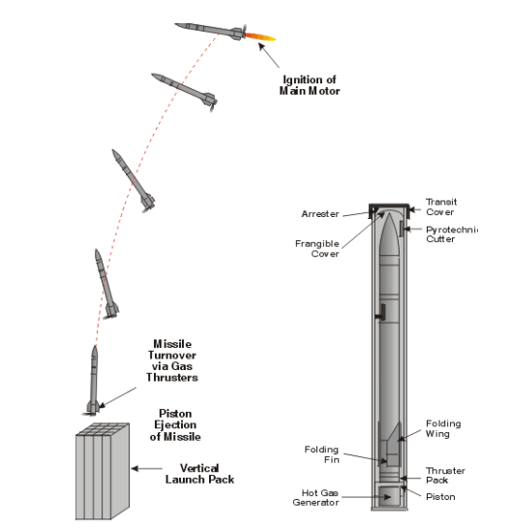

**Fig. 1** SVL Concept

The ejection system imparts the missile with an exit velocity allowing it to achieve the optimum turnover altitude within the required time. All ejection effects are contained in the canister. All ejection loads are transferred through the canister down to the surface.

For GBAD, the missile is turned over towards the target predicted intercept point by means of a solid propellant, rocket powered, thruster providing lateral control in pitch, yaw and roll. Once turned over, the missile boost motor is then ignited. A smoother and more direct missile turnover is possible enabling rapid target acquisition, by the seeker, for minimum range engagements.

This approach eliminates the need for a complex efflux management system and a simpler, lightweight launcher can be used. This in turn means that there is no restriction to launch site or its proximity to ground troops. Deployment in urban areas is only limited by the requirements of surveillance and alerting devices.

The SVL launcher would consist of the tube with electrical interfaces for operation and test together with the ejector mechanism. This would be a unified design made in selected dimensions that could be configured to provide multiple launch containers. Once loaded with the missile the tubes would be hermetically sealed.

For GBAD operations the launch containers can be deployed on a variety of standard UK Army vehicles, either tracked or wheeled. At the launch site these containers can remain located with the vehicle or be deployed remotely.

Alternatively, containers deploying canistered SVLTM missiles could be temporary structures on board ships. These containers could be transported with an amphibious force, or helicopter, for use on land. The container could therefore be deployed as a multi-role and multi-service launcher (Figure 2).

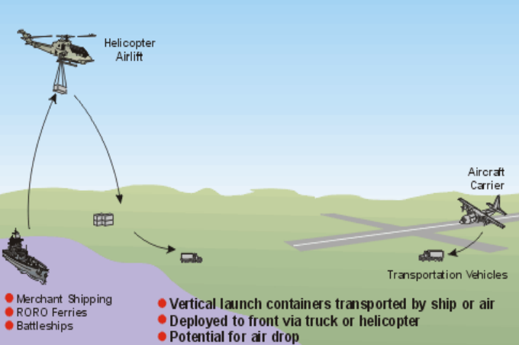

**Fig. 2** Joint Service Use

SVL is a technique that can be used to launch short or longer range missiles of differing types, thus providing the potential for different threats to be engaged using the same launcher. It also has the potential to be used for horizontal launch of missiles from platforms that cannot accept a severe launch environment (blast, noise or heat) such as small craft and helicopters.

Thus SVL facilitates a more flexible response to target variety and offers the potential to change the weapons mix without affecting the overall configuration of the carrier platform. Figure 2 illustrates the concept for a SVLTM launcher that has been configured to launch a mix of weapons - short and medium range missiles, countermeasures, and potentially micro-UAV’s.

***9.3. MANPADS launcher***

In basic terms, the typical MANPADS system consists of: (1) a missile packaged in a tube which includes a seeker head, (2) a launching mechanism commonly called a “gripstock,” and (3) a battery (Figure 1). Under optimum conditions, an expert operator can assemble, shoulder, and launch a missile in 30 seconds. Most versions are effective against fast-moving targets up to 15,000 +/- feet in altitude and three-to-five miles in range.

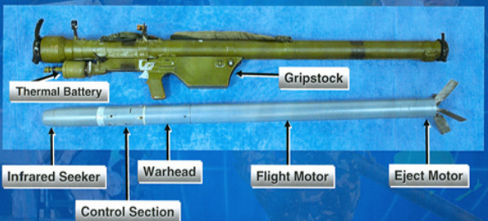

**Fig. 1** MANPADS Components

In terms of logistical convenience, most are five to six feet in length and weigh between 35 and 40 pounds. They are normally hermetically sealed in launchers and designed for field conditions and rough handling to minimize environmental degradation. In terms of shelf life, some MANPADS are advertised with 22 years of operability under factory-specified conditions.

While field conditions are generally not conducive to maximum lifespan, the SA-7B Strela-2Ms used in the Mombassa attack were approximately 28 years old. Battery life is probably the single-most restrictive component of a MANPADS. A popular misconception once followed that some of the Afghan-era Stingers were obsolete because of battery failure and this was not true! The original batteries for these systems can be replaced with commercially available substitutes found on the open market, thus making many weapons once believed to be obsolete, very much a threat.

Once launched, a MANPADS tracks and impacts its target in approximately five seconds. Most accelerate to velocities approximately twice the speed of sound, Mach 2, in less than two seconds and maneuver at G-loadings far greater than any transport category aircraft is capable of attempting. While they vary tremendously in terms of capability, most use an infrared (IR) seeker to detect an aircraft’s IR signature against the cold sky and home into the heat emitted from hot metal sections of the aircraft engines and exhaust. The seeker head of a MANPADS serves as its brains and defines the overall system in terms of guidance. Three main types of seekers exist including IR, command line-of-sight (CLOS) - meaning radio controlled, and laser beam riders.

IR missiles use passive guidance, meaning they emit no signals until they are fired, which makes them extremely difficult to detect during their short, five to six second flight path. As an aircraft flies through the sky, it naturally emits energy as IR, visible, and ultraviolet (UV) parts of the electromagnetic spectrum. Just as humans see visible light, the IR seeker head sees IR energy and attempts to guide its payload to the given target. With technological and computing speed advances over the years, IR seeker technology varies tremendously in terms of capability. With this, IR missiles are classified according to sophistication and denoted as first, second, third, and fourth generations. Russian SA series MANPADS increase in sophistication as their nomenclature increases with the first generation SA-7 being the least sophisticated.

First generation IR missiles are tail chase weapons that must pursue their targets from behind. They essentially chase the hottest item in the sky such as the thermal signature from the exhaust and hot sections of the aircraft. Because of this, they are highly susceptible to interference from background sources such as the sun, flares, and various directed energy countermeasures which will be discussed later. First generation IR MANPADS include the American Redeye, Soviet SA-7, and the Chinese HN-5. The SA-7 Strela-2 (NATO: Grail) and its variants are the most widely deployed first generation MANPADS with thousands in existence today.

Second generation IR variants include the American Stinger, the Soviet SA-14 Strela-3 (NATO: Gremlin), SA-16 Igla-1 (NATO: Gimlet), and the Chinese FN-6. All of these use coolants to cool the conical scanning seeker head and in turn filter out most interfering background IR sources as well as permitting head-on and side engagement profiles.These second generation missiles are effective against traditional flares and use a cross-scan or rosette-scan “two-color” targeting capability. This enables the seeker to use IR as a primary and UV as a secondary emissions source for target acquisition.

Third generation IR systems include the French Matra Mistral, the Russian SA-18 Igla (NATO: Grouse), the Pakistani Anza Mk II, and the American Stinger B. These scan multiple color bands and produce a quasi-image of the target and are essentially flare-proof (traditional and advanced). Finally, fourth generation IR missiles include the Stinger Block 2 and others in development in Russia, Japan, France, and Israel that use focal plane array guidance for greater engagement range.

CLOS missiles are guided to the target by a human operator who flies the missile into the victim aircraft using radio controls. Standard aircraft mounted countermeasure systems are not effective against this type of missile. Unlike IR guided systems which are essentially fire-and-forget weapons, CLOS require highly trained operators, thus making them less appealing to terrorist organizations.

Laser beam riding MANPADS follow a laser beam aimed by a human operator to its intended target. Like CLOS systems, laser beam riders are resistant to current aircraft mounted countermeasure systems and cannot be jammed after they are launched. Existing systems include the Swedish RBS-70 and the British Starstreak. While this system does require extensive training, it is more user-friendly and particularly menacing in the hands of a well-trained adversary.