5. GUIDANCE SEEKER

5.1. Introduction
A missile seeker is composed of a seeker head to collect and detect energy from the target, a tracking function to keep the seeker boresight axis pointed toward the target, and a processing function to extract useful information from the detection and tracking circuits.
The seeker usually is mounted in the nose of the missile where it can have an unobstructed view ahead. The seeker antenna or optical system is usually mounted on gimbals to permit its central viewing direction (boresight axis) to be rotated in both azimuth and elevation relative to the missile centerline). The limits of the angular viewing direction (gimbal angle limits) are typically about + 40 to + 60 deg relative to the centerline axis of the missile. If the angle between the missile centerline and the line-of-sight to the target exceeds the gimbal angle limits, the seeker is physically constrained by the gimbal stops and can no longer track the target.
The gimbaled portion of the seeker head usually is stabilized to keep it pointing in a fixed direction regardless of perturbing angular motions of the missile body. The two most prevalent means of stabilization are to spin a portion of the gimballed components so that they act as a gyro and to use actuators to hold the seeker in a stabilized direction using control signals from gyros mounted on the gimbal frames. In either case, signals from the tracking circuitry are required to change the pointing direction of the seeker.
The two common seeker types are optical and radio frequency (RF). The methods and equipment used to sense signals in the optical and RF bands are different so they lead to different implementations of the two types of seekers.

5.2. Optical Seekers
Seekers that sense radiation in the ultraviolet (UV), visual, and infrared (IR) portions of the electromagnetic spectrum are classed as optical seekers. The radiation is transmitted through the atmosphere from the target. Not all target radiation directed toward the seeker will reach it because of attenuation. Optical radiation is attenuated by the geometrical distance from the source (inverse range squared); by absorption and scattering by the atmosphere; by clouds, haze, rain, and snow, and by other obscurants such as smoke and dust. The amount of attenuation is influenced by the wavelength of the radiation.
For example, there are atmospheric transmission windows (relatively lower attenuation) at wavelengths of 1-3 $μ$m, 3-5 $μ$m, and 8-12 $μ$m in the IR spectral region (Figure 1). IR radiation outside these windows is attenuated so severely by the atmosphere that only these windows are used for IR sensors. The 1-3 $μ$m band was used by early IR seekers, which were not cooled. The 3-5$μ$m band is the most applicable to current cooled IR seekers. Little of the radiation from the target exhaust plume is contained in the 8-12 $μ$m band; thus this band is less desirable for surface-to-air missiles. The visible spectrum is transmitted through a window from 0.4 to 0.8 $μ$m, and an ultraviolet window exists from 0.34 to 0.39 $μ$m. Some seekers are designed to use more than one optical band to discriminate between targets and decoys.
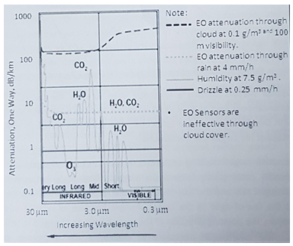
Fig. 1 Attenuation of Optical Radiation

Sources of optical radiation that can be used by seekers are the engine exhaust plume, hot metal, and aerodynamic heating. In the visible portion of the spectrum, reflected sunlight can be used. UV radiation is transmitted to the seeker from the background scene. The target blocks out UV radiation and provides contrast with the background. A laser seeker would of course use reflected laser radiation. The distribution of IR radiation from a typical target is shown in Figure 2.
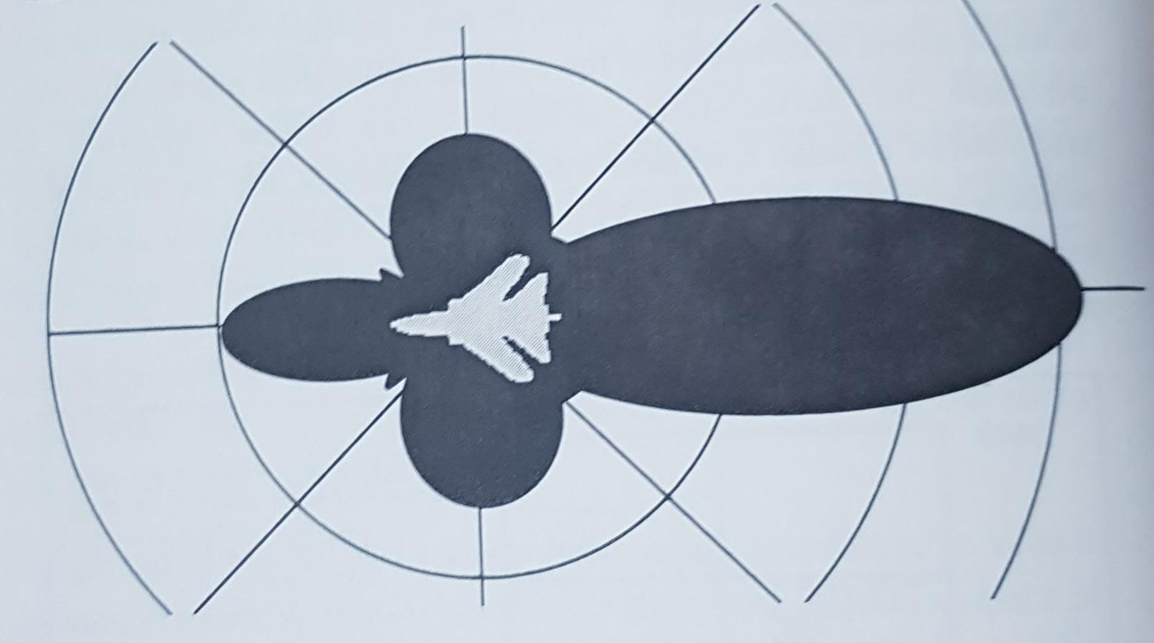
Fig. 2 Distribution of IR Radiation from a Typical Target
When the target exhaust plume is used as the primary source of radiation being sensed by the seeker, it is necessary to bias the guidance ahead of the plume for crossing (other than head-on or tail-on) engagements; otherwise, the missile will pass through the plume behind the target.
Optical seekers contain a telescope used to view the target. The instantaneous field of view (FOV) is conical, and the cone axis coincides with the optics axis of the telescope. The telescope forms an optical image of the target and background.
Accurate target tracking requires that the seeker boresight axis be pointed continuously toward the target. The angle between the boresight axis and the line-of-sight to the target is the tracking error. As the line-of-sight to the target changes because of relative target motion, the pointing direction of the seeker must be changed to follow it. The information necessary to determine the magnitude and direction of the tracking error is contained in the telescope image. Different methods of extracting the target error have been developed. All employ photoelectric devices, called detectors, to convert information contained in the optical telescope image into an electrical signal suitable for processing.
There are three types of optical seekers based on the different techniques used to process the optical image. These methods are reticle, pseudo-imaging, and imaging. Each method is discussed in the sections that follow.

5.2.1. Reticle
The simplest form of optical seeker directs the entire telescope image onto a single detector. This image contains the sum of the radiant power from the background scene and from the target. One approach to extracting the tracking error from the image is to pass the image through an optical device (reticle) designed to encode the tracking error.
The basic arrangement of the reticle tracker is illustrated in Figure 3. A cross-sectional view of a typical reticle seeker and the optical ray paths through the telescope are shown in Figure 4. The telescope collects optical radiation and focuses an image of the field of view on the reticle. The reticle, located between the telescope and the detector, contains a spatial pattern of varying optical transmission. Some parts of the pattern block that portion of the image that is focused upon them; other parts allow the image to pass through to the detector. The transparent and opaque areas are arranged so that the modulation (passing and blocking of energy) encodes the position of the small sources relative to the boresight axis and discriminates against larger sources in the background. The modulated radiation is collected and deposited on the detector, which produces an electrical signal proportional to the amount of incident radiant power. The seeker electronics amplify this detector signal and demodulate it to recover an error signal that represents the tracking error. The error signal is fed back to point the telescope such that the error is reduced.
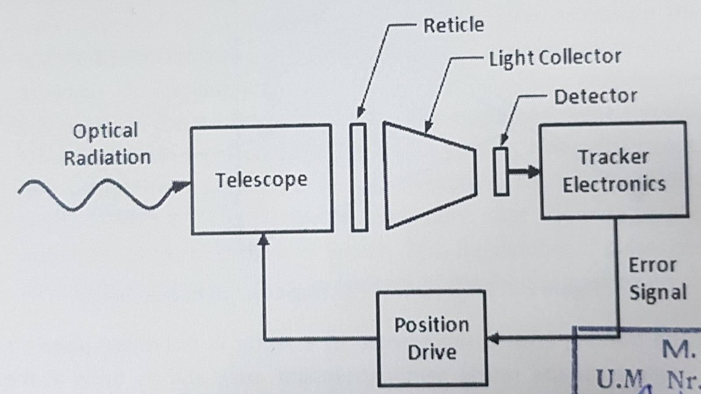
Fig. 3 Basic Reticle Tracker
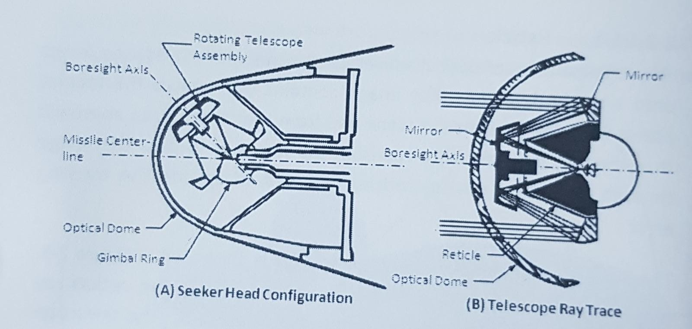
Fig. 4 Typical Conical-Scan Reticle Seeker Assembly
To measure the tracking error, the position of the target is projected on the plane of the reticle as shown in Figure 5.
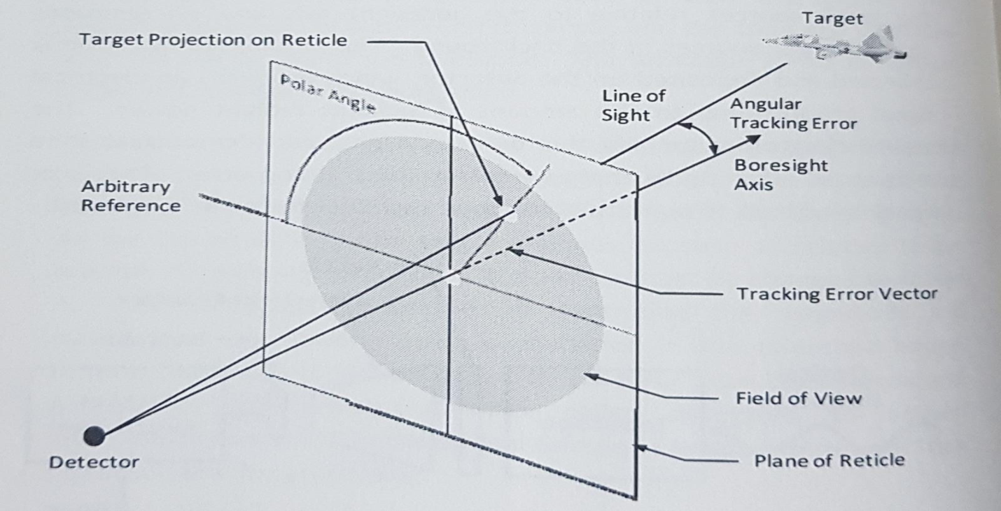
Fig. 5 Projection of Tracking Error on Reticle Plane

The tracking error is represented by a vector in the reticle plane. Its origin is at the reticle center (boresight axis), and its tip is at the intersection of the target line-of-sight and the reticle plane. This vector is quantified by its polar angle, which is relative to an arbitrary reference, and its magnitude, which is proportional to the angular tracking error. The tracking error magnitude is measured as a radial distance on the reticle. The minimum information required for tracking is the polar angle. For proportional control, it is necessary also to have a signal indicating the radial component.
The passing and blocking of target energy requires relative motion between the reticle and the target image. There are two common methods used to provide this motion. One is spinning the reticle about the boresight axis (spin scan). The other is employing a stationary reticle and conically rotating (notating) the telescope optical axis about the bore-sight axis (conical scan). When a spin-scan seeker is tracking perfectly, the target appears at the center of the field of view, and the target image is focused on the center of the reticle. Tracking by a conical scan seeker causes the target image to rotate in a circle because of the coning motion of the telescope. Perfect tracking causes the target circle to be concentric with the reticle pattern, which is centered on the boresight axis.
In spin-scan seekers the reticle rotation produces a signal consisting of pulses as the target image is chopped by the reticle pattern. Figure 6(A) shows an example of a spin-scan reticle.
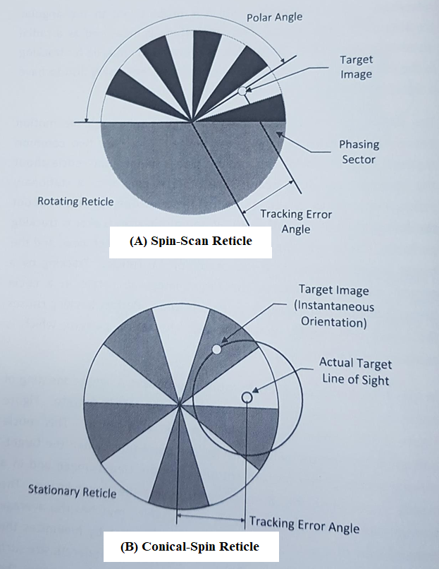
Fig. 6 Genetic Reticle Patterns

This reticle pattern is asymmetric, which results in a pulse-burst when the target- sensing sector of the pattern rotates over the target image and in a steady signal when the phasing sector covers the target image. The transmission of the phasing sector is 0.5, which matches the average transmission of the target-sensing sector and thereby minimizes the signal modulation caused by background objects of moderate size such as clouds. The phase of the modulated signal envelope encodes the polar angle of the tracking error vector. The magnitude of the tracking error vector can be encoded if the reticle pattern has radial bands, each with different numbers of image interrupters. This pattern gives a variable number of pulses in the pulse burst that depends on the magnitude of the tracking error vector. Thus the number of pulses per pulse burst is a measure of the magnitude of the angular tracking error.
A major limitation of spin-scan trackers is that the carrier signal is lost when the tracking error is near zero; thus low tracking precision results. This limitation is overcome by conical scan trackers. In this case, a constant frequency signal is generated when the tracking error is near zero because the target image traces a circular path concentric with the reticle pattern. As the target position moves off-axis, as shown in Figure 6(B), the circular path of the target image is no longer concentric with the reticle pattern. Thus a phased modulation is produced that accurately indicates the target polar and radial position components in the field of view.
If the target image path on the reticle passes over pattern regions of uniform width, as in the spin-scan pattern of Figure 6(A), an amplitude modulation (AM) demodulator is used to process the signal. If the target image passes over varying widths of reticle pattern, as in the conical scan pattern of Figure 6(B), a frequency modulation (FM) demodulator is used.

5.2.2. Pseudo-imaging
The continuing search for better methods of discriminating the background from the target and for discriminating between decoys and targets led to the development of pseudo-imaging seekers. These seekers provide some of the advantages of fully imaging seekers (such as television cameras) but with less complexity. Although some of the features of the scene can be derived electronically, a full image is not developed. The tracking system used in pseudo-imaging seekers is in the general class called scanning trackers. In general, scanning trackers incorporate one or more detectors that have instantaneous fields of view that are small fractions of the total field of view. These detectors scan the total field of view repeated y and thereby transform the scanned scene into a set of detector signals. Reference signals are also generated derived from the scan motions that represent the instantaneous position of each detector field of view within the total field of view. The signal processor identifies the target signal in the detector outputs, usually by a thresholding process, and samples the reference signals at that time to determine the target position in the field of view. These position signals are then used to point the seeker so that the target is centered within the total field of view.
Pseudo-imaging seekers have numerous performance advantages over reticle seekers. The instantaneous field of view of each detector is smaller than that of reticle seekers, so it gives smaller background signals. On the other hand, pseudo-imaging seekers do not lend themselves to optical spatial filtering, as afforded by reticles, to suppress large background objects. The burden of background rejection for pseudo-imaging seekers is transferred to the signal processor. With relatively small instantaneous fields of view, pseudo- imaging seekers preserve more of the scene information in the detector signals than reticle seekers. This permits resolution of multiple targets and selection of the desired target based upon observable criteria. For extended targets, i.e., larger than the instantaneous field of view of a detector, the signal processor can be designed to track a particular point on the target, such as the centroid, an edge, or some other identifiable point. Pseudo-imaging seekers naturally lend themselves to the use of digital signal processing since the signal processors for this class of systems usually contain a substantial number of logic functions.
The rosette pattern, illustrated in Figure 7, is an important scan pattern for pseudo-imaging seekers. The rosette scan seeker uses a single detector with a scan pattern that contains a number of loops, or petals, emanating from a common center. A rosette scan is easily mechanized by means of two counter-rotating optical elements, each of which deflects incoming rays by the same angle. The deflection elements can be optical prisms, tilted mirrors, or off-centered lenses. At any given instant only one point from the scene is focused on the detector. The relative positions of features in the scene can be determined since the relative pointing direction within the rosette scan is known at the moment each feature is detected.
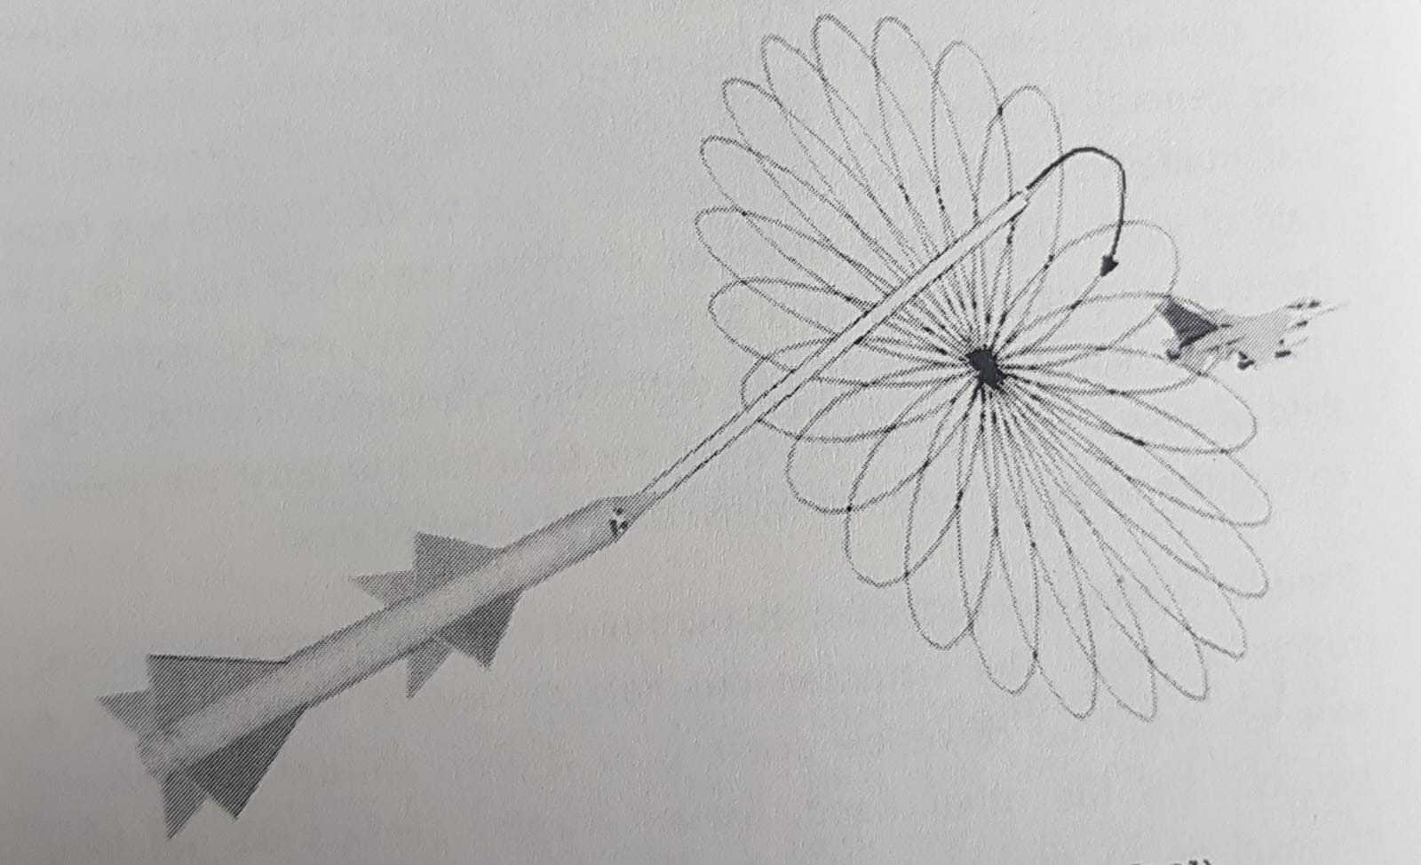
Fig. 7 Rosette pattern

5.2.3. Imaging
An imaging seeker uses either single or multiple detectors that produce video signals by means of a raster scan of the target scene. Imaging sensors generally preserve more scene information than non-imaging sensors; thus imaging seekers can discriminate between objects by various criteria. This feature satisfies performance requirements beyond the capabilities of most non-imaging seekers.
The primary advantages of an imaging seeker are its resistance to countermeasures, its discrimination of background and its contributions to fuze logic. Examples of imaging sensors are television cameras and focal plane array devices. A focal plane array is a pattern of individual detectors for the purpose of imaging. There are two basic methods of imaging with detector arrays. One is to focus the entire scene optically on a two-dimensional array and sample each element electronically by using a raster scan to produce scene images. The other method is to scan the scene mechanically to generate image data from a relatively small number of detectors. Systems that image only a portion of the total field of view on the focal plane array and move this instantaneous field of view about to cover the total field of view operate in a scanning mode. Systems that image the total field of view on the focal plane array operate in a staring mode. One current approach to image processing is to couple a focal plane array with a microprocessor containing a pattern recognition algorithm to recognize and identify targets automatically.

5.3. Radio Frequency Seekers
An RF seeker is essentially a radar in which the antenna is employed to collect RF radiation reflected horn the target. The RF power maybe generated by systems onboard the target, by a target illuminator on the ground or by a transmitter onboard the missile.
A passive RF seeker receives radiation generated by the target. A semiactive seeker receives reflected target echoes of radiation originally generated by a ground-based illuminator. An active seeker receives target echoes of radiation originally generated and transmitted from onboard the missile.
Various transmitted waveforms and processing methods are used to exact information. Seeker radar antennas take various physical forms, but the most common are parabolic dish or planar array antennas mounted on gimbals. A typical radar seeker employing a gimballed planar array is shown in Figure 8.
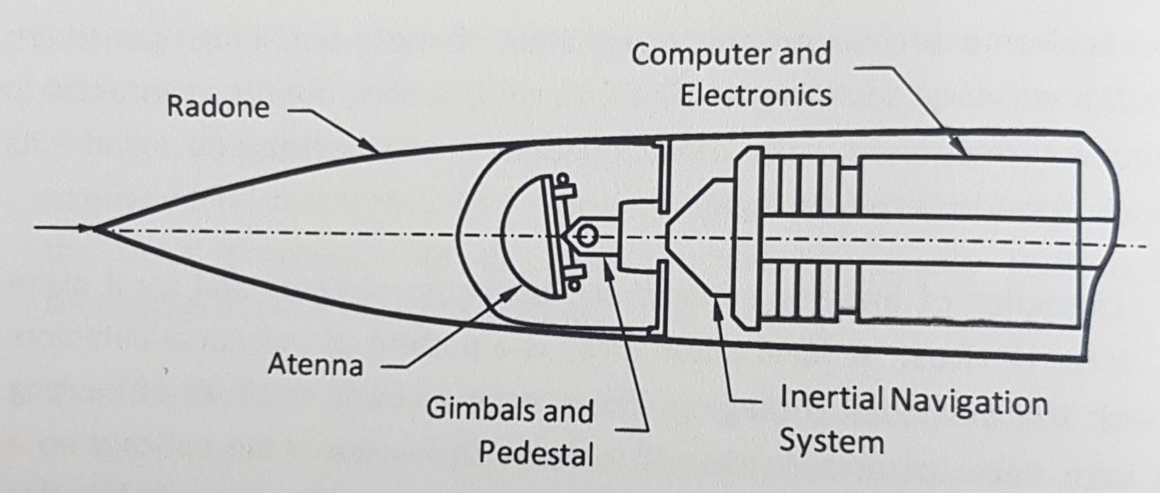
Fig. 8 Radar Seeker

Two-way attenuation of RF radiation by atmospheric effects is shown in Figure 9 as a function of radiation frequency. Scattering losses caused by fog, drizzle, and rainfall are not significant y greater than they are for the standard atmosphere at frequencies below 3 GHz, but they rapidly become significant at frequencies greater than 10 GHz.
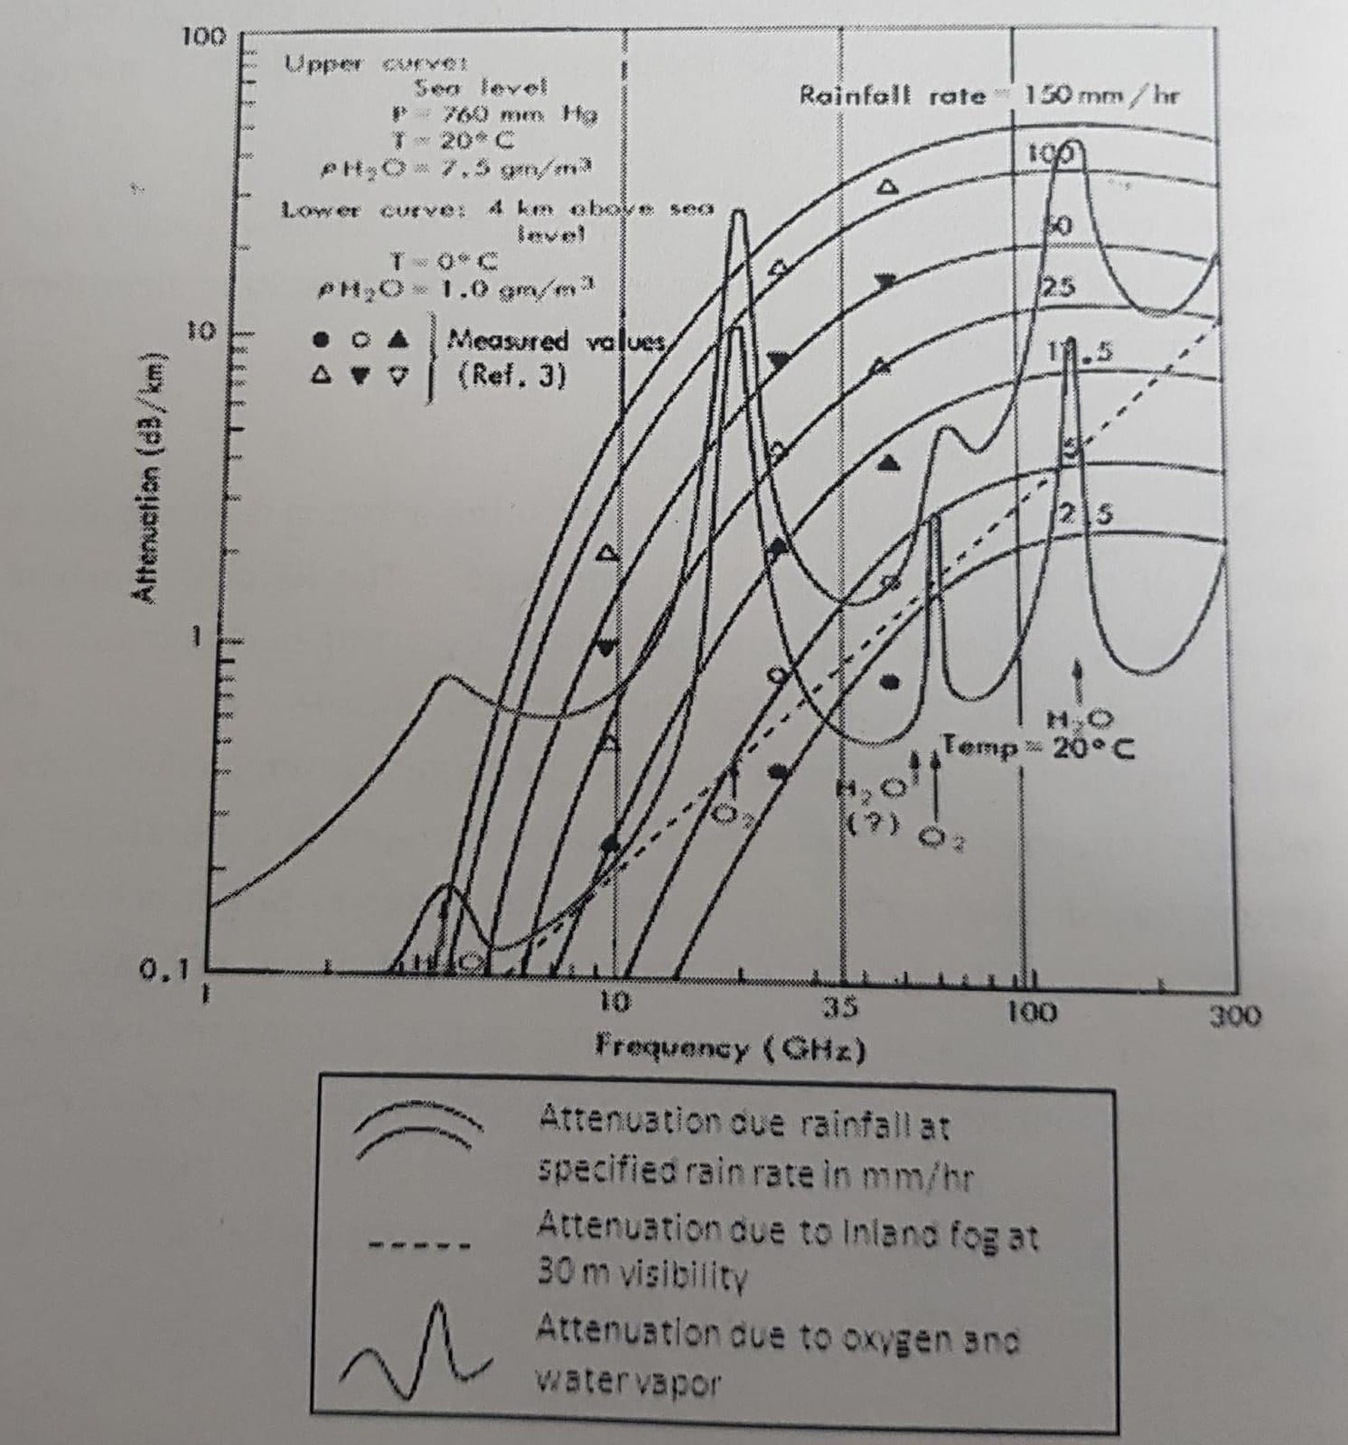
Fig. 9 Attenuation of RF Radiation by Atmosphere and Rain

Passive techniques are being employed in the design of new aircraft to decrease their RF — signatures. Sophisticated _ electronic countermeasures (ECM) equipment is carried onboard aircraft to produce clutter or to introduce deceptive or confusing signals into the signal processors of the RF seeker. RF expendable decoys with signatures greater than the signature of the target have the potential to attract RF missiles away from the target. Missile seeker counter-countermeasures (CCM) techniques include Doppler and range tracking and sophisticated signal processing.
The basic radar types applicable to surface-to-air missiles are pulse radars, continuous wave (CW) radars, and pulse Doppler radars. Seekers employing these radar types can be active, semiactive, or passive.

5.3.1. Pulse Radar
Pulse radar transmits a relatively short burst of electromagnetic energy, and the receiver listens for the echo. The antenna is designed to receive energy in one or more relatively narrow (pencil) beams (also called lobes). The echo received from targets in these beams is used to track the target. Range to the target can also be determined by observing the time it takes for the pulse to return.

5.3.2. Continuous Wave Radar
Continuous wave (CW) radar transmits continuously rather than by pulses, and as a result it cannot determine the range to the target without some additional modulation. The change in frequency between the transmitted signal and the echo, caused by the Doppler Effect, can be used to determine the component of relative target velocity along the line-of-sight. This is useful for discriminating the moving target from stationary clutter or from decoys that have velocities different from that of the target. CW radars have two major disadvantages. One is the inability to measure range; the second is the transmitter signals leak directly into the receiver, a disadvantage that requires excellent system stability and large dynamic range to give good performance.

5.3.3. Pulse Doppler Radar
Pulse Doppler radar combines the pulse operation with the use of Doppler from the CW radar to measure directly both range and range rate or radial velocity of targets. The Doppler principle makes it possible for CW radar to detect a moving target, and it permits pulse radar to detect a weak signal from a moving target in the presence of strong clutter signals. By using Doppler shift and special filters, the return from a moving target can be detected by pulse Doppler radar. This is referred to as moving target indicator (MTI).
This type of radar transmits pulses just as the pulse radar does and can, therefore, use time to determine range. Also, when the signal is received, its frequency can be compared with the transmitter frequency to determine radial velocity based on the frequency (Doppler) shift. Use of Doppler filters permits tracking the target in velocity, a useful discriminator against some types of countermeasures. Because the bandwidth of the pulses is large relative to Doppler frequency shifts, the signal must be coherent in order to measure velocity. A coherent signal is one in which the phase is consistent from one pulse to the next, as if each pulse had been cut from a single continuous wave. Another useful feature of coherent pulse Doppler radars is that they are better able to discriminate against noise than non-coherent radars.
Use of the Doppler effect to discriminate clutter makes possible a reliable capability of looking down against the earth background under certain engagement conditions, tracking in frequency (velocity gating) and range (range gating) is a powerful tool used to discriminate against decoys.

5.4. Angle Tracking Methods
Several methods are used to detect angular errors in tracking a target with radar. Among these are sequential lobbing, conical scanning, and two forms of monopulse tracking. All of these methods are based on the same general principles but are implemented in slightly different ways, they all make use of the fact that the magnitude (or phase) of the target return signal depends on the angle between the fine-of-sight to the target and the axis of the radar antenna lobe pattern. When the target is located exactly on the lobe axis, the magnitude of the target return signal Is greatest, Other factors, however, also affect the magnitude of the target signal, such as target radar cross-section, aspect angle, and range. Therefore, a single lobe is not sufficient to determine the magnitude of the angular tracking error.
Also the radial direction of the tracking error cannot be determined from a single lobe because of lobe symmetry about its axis.
Tracking usually is implemented by using two separate tracking channels-one corresponds to the azimuth plane and the other to the elevation plane. At least two lobes in each plane are required to determine the components of the tracking error (Figure 10(A)). Ina given plane the axes of the two lobes are separated from each other by a small angle and are symmetric about the boresight axis of the tracker.
Target strength is measured in each lobe and converted to a voltage. The voltage difference between the two lobes is a measure of the tracking error. A target line-of-sight coincident with the tracker boresight axis (zero tracking error) forms equal angles with each of the radar lobe axes, and the voltage difference between the signals horn the lobes is zero, which indicates zero tracking error. As the target moves off the tracking boresight axis, it moves away from one lobe and toward the other and creates a voltage difference between the lobes, as shown in Figure 10(A).
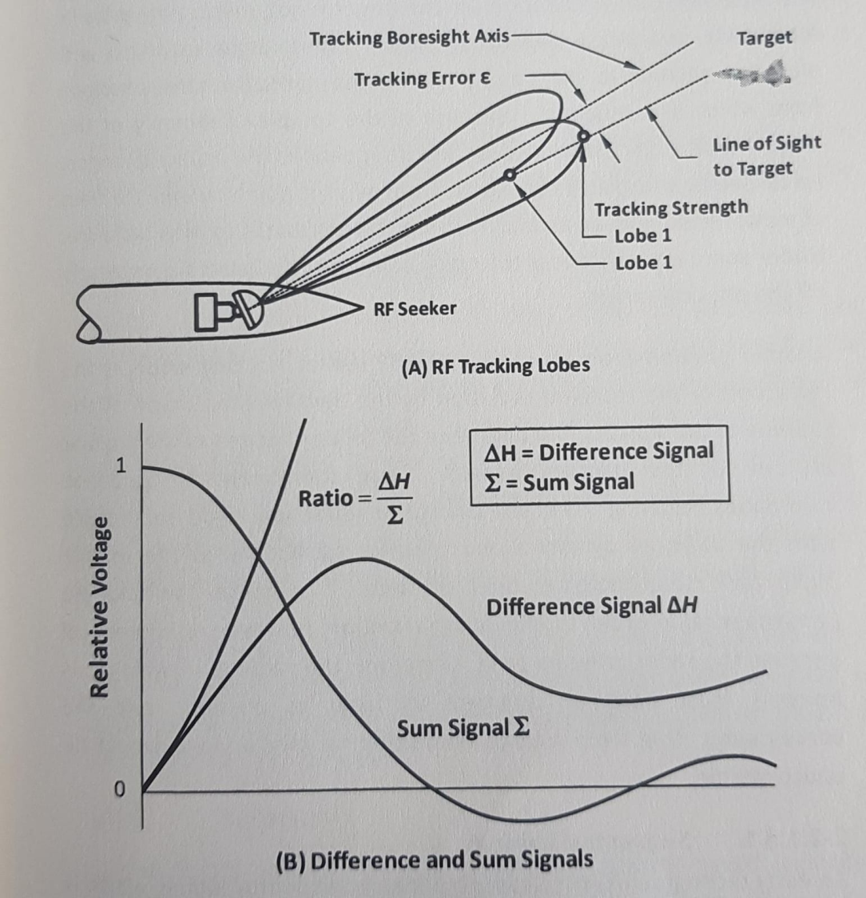
Fig. 10 Angle Tracking Methods

For small tracking errors this difference is approximately proportional to the magnitude of the tracking error as shown in Figure 10(B). In practice, the voltage difference normalized by the voltage sum ∑ is used to indicate the magnitude and direction of the tracking error.
The reflection of RF radiation from the target is not uniform; it varies in magnitude and phase depending on the aspect angle (azimuth and elevation relative to the target) and on the particular target surface from which it is reflected. Because of the complex geometry of the target surface, glint points occur and disappear as the aspect changes. An RF seeker integrates the signals from all glint points within the field of view, resulting in an erratic track which contributes to miss distance. Under some circumstances the track point may be located completely off the physical target.
Another phenomenon contributing to RF seeker tracking errors is the refraction of the received radiation by the aerodynamic shape of the radome of the seeker. The degree of refraction changes as the angular attitude of the missile changes. The component of guidance commands resulting from this change in refraction angle can couple with the airframe dynamics and produce oscillations in the missile flight path that increase miss distance. To make the radome hemispherical in order to eliminate refraction, however, is impractical because the radar antenna (and, therefore, the radome in which it is housed) must have an aperture as large as possible, and the aerodynamic drag from a large hemispherical missile nose would be unacceptable.

5.4.1. Sequential Lobbing
An early technique used for radar tracking is sequential lobbing, which is switching the antenna boresight from one side of the tracked target to the other. The amplitudes of the returns will be equal when the target is centered between the switched positions of the antenna. If the target is not centered, the amplitudes will differ; this difference is the tracking error signal. A major disadvantage of sequential lobbing is that the target signal strength can fluctuate during the short interval required to switch lobes, which introduces errors into the estimate of the tracking error.

5.4.2. Conical Scanning
Conical scanning is implemented by scanning the axis of a single beam around the surface of a cone with the cone apex at the radar and the cone axis coincident with the boresight axis of the tracker. Once each revolution, the beam appears on either side of the cone axis in a given plane. Target return signals are measured and compared for these two lobe positions for each tracking channel in order to estimate tracking error. The disadvantage of target fluctuations between lobes also is inherent in conical scanning.
Although it is similar to sequential lobing, conical scan is preferred in most applications since it suffers less loss of signal strength and the antenna systems are usually less complex.

5.4.3. Monopulse Tracking
As its name implies, monopulse tracking forms the two lobes per tracking plane with a single pulse. That is, both lobes are formed at the same time; thus the problem of target fluctuation between lobes is eliminated. One implementation of monopulse tracking uses amplitude comparison of the target return signals to estimate the tracking error, as in sequential lobbing and conical scanning. The other implementation makes use of the fact that the phase difference between the two returns is proportional to the angular tracking error.
Monopulse radar provides a better tracking technique than the other types of radars, but in many applications in which the ultimate in performance is not needed, the conical-scan radar is used because it is less costly and less complex.

