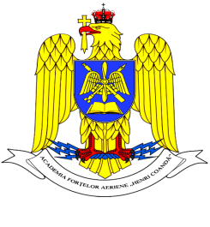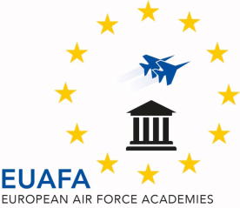

**ROMANIA**

**MINISTRY OF NATIONAL DEFENSE**

**“Henri Coanda”**

**AIR FORCE ACADEMY**





**INTERNATIONAL WEEK**

**22 – 27 March, 2020**

Please fill in the form and send it by **15th January 2020**, to:

* LtCol Cosmina-Oana ROMAN, PhD, Vice-Rector for Programs and International Relations at “Henri Coandă” Air Force Academy: [internationalweek@afahc.ro](mailto:internationalweek@afahc.ro);

cc: [roman.cosmina@afahc.ro](mailto:roman.cosmina@afahc.ro);

Delegation info:

|  |  |  |
| --- | --- | --- |
| Country |  | |
| Academy/Institution |  | |
|  |
|  | CADET 1 | CADET 2 |
| First name |  |  |
| Last name |  |  |
| Rank |  |  |
| Gender |  |  |
| Cell phone number, with country code |  |  |
| Personal e-mail address |  |  |
| Passport number and  date of expiry |  |  |
| Food allergy or special diet |  |  |

|  |  |  |  |  |  |
| --- | --- | --- | --- | --- | --- |
| **TRAVEL PLANS** | | | | | |
|  | **Date** | **Time** | | **Flight/train number** | **Location/Airport** |
| * **Arrival information** |  | |  |  |  |
| * **Departure information** |  | |  |  |  |

**Any comment or special request**: ……………………………………………………………… …………………………………………………………………………………………….…………………..………………………………………………………………………………………...…………………………………………………………………………………………………………….